

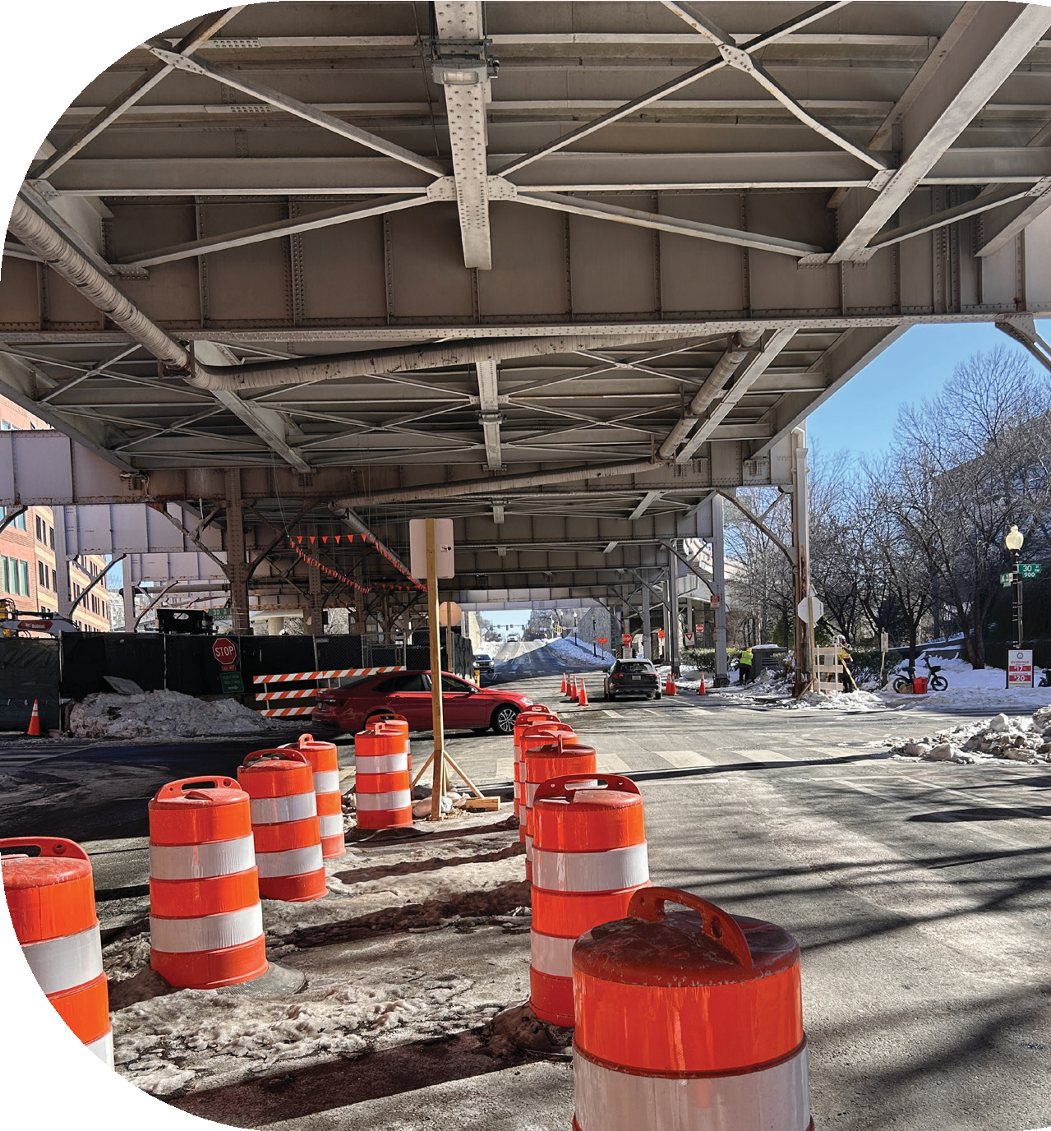


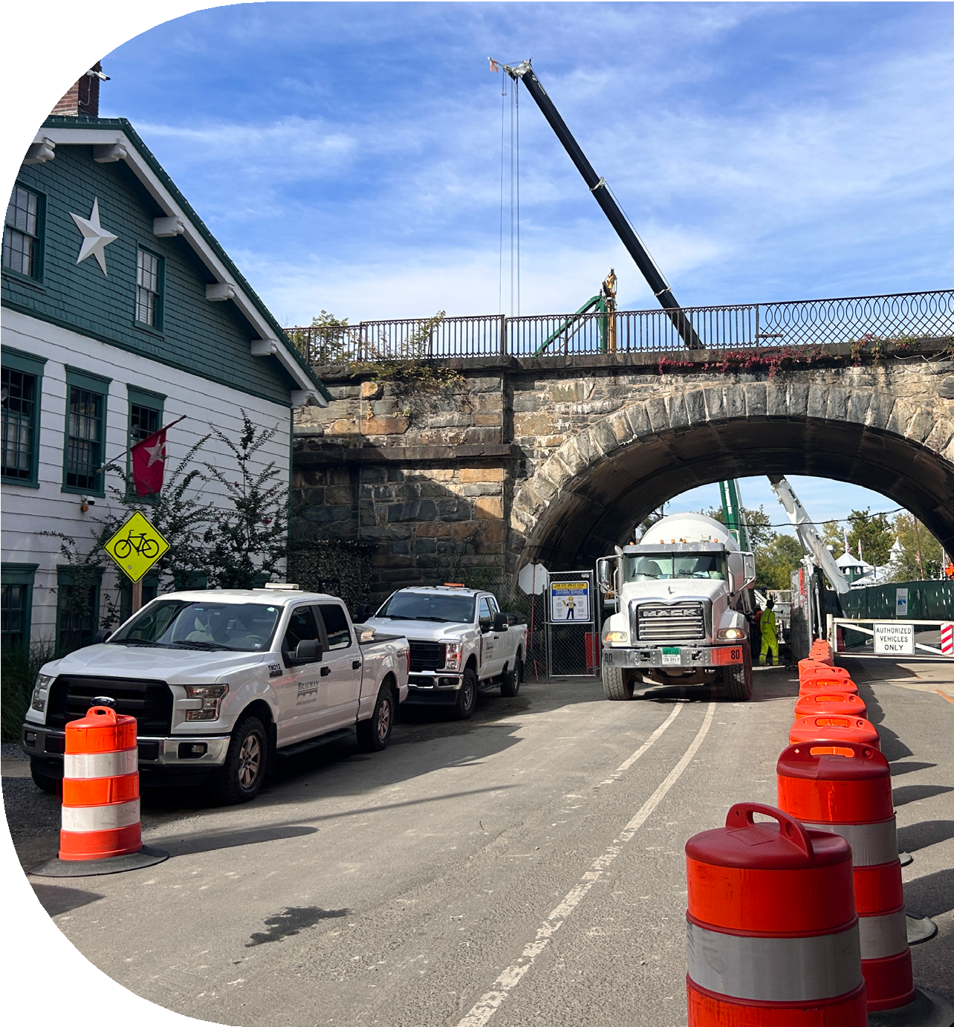
YOU’RE INVITED!

GEORGETOWN TUNNEL FORUM
DC WATER’S POTOMAC RIVER TUNNEL PROJECT

DATE: NOVEMBER 12, 2026
DATE: FEBRUARY 26, 2026 TIME: 6:30 PM–7:30 PM
LOCATION: VIRTUAL (MICROSOFT TEAMS)
TIME: 6:30 - 7:30 PM LOCATION: VIRTUAL (MICROSOFT TEAMS)

Join us for a Potomac River Tunnel Forum. Learn what construction activities are planned in Georgetown over the coming months and how they may affect travel, access, and recreation in your neighborhood.
Join us to learn about upcoming

for the Potomac River Tunnel work in Georgetown, including:
K STREET & 30TH STREET NW GEORGETOWN WATERFRONT PARK CAPITAL CRESCENT TRAIL

Meet the project team, ask questions, and get the latest information on work planned near: K STREET & 30TH STREET NW GEORGETOWN WATERFRONT PARK CAPITAL CRESCENT TRAIL

Join Online:
https://tinyurl.com/GeorgetownTF-Oct
Meeting ID:
279 447 485 245 656
Passcode: r2gX9426
Call-In: 202-753-6714
354 860 501#
T
U
N
N
E
L
P
R
O
J
E
C
T
P
O
T
O
M
A
C
R
I
V
E
R

