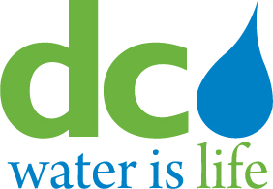
DISTRICT OF COLUMBIA
WATER AND SEWER AUTHORITY

Board of Directors

GM’s Performance Review Committee

Monday, June 17, 2019

9:00 a.m.

- Call to Order Tommy Wells, Chairperson

- Executive Session

- Adjournment Tommy Wells, Chairperson

