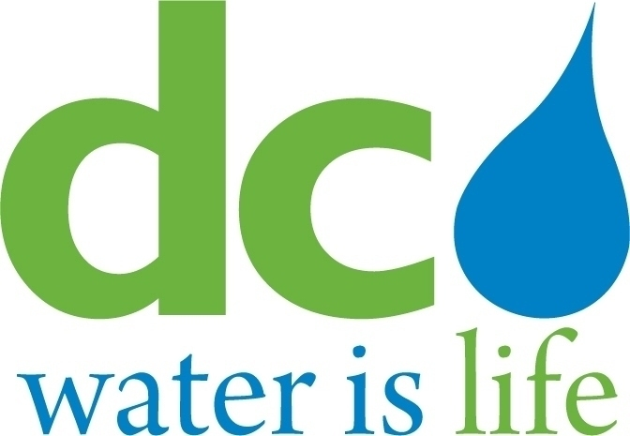

DISTRICT OF COLUMBIA
WATER AND SEWER AUTHORITY

Board of Directors

Executive Committee

Wednesday, September 2, 2020
9:00 a.m.

- Call to Order… ....................................................…..,,,,,,,,.Tommy Wells
Chairman

- Roll Call………………………………………………………….Linda Manley
Board Secretary

- Executive Session……………………………………………..Tommy Wells
Chairman

- Adjournment ..........................................................................Tommy Wells
Chairman

