.
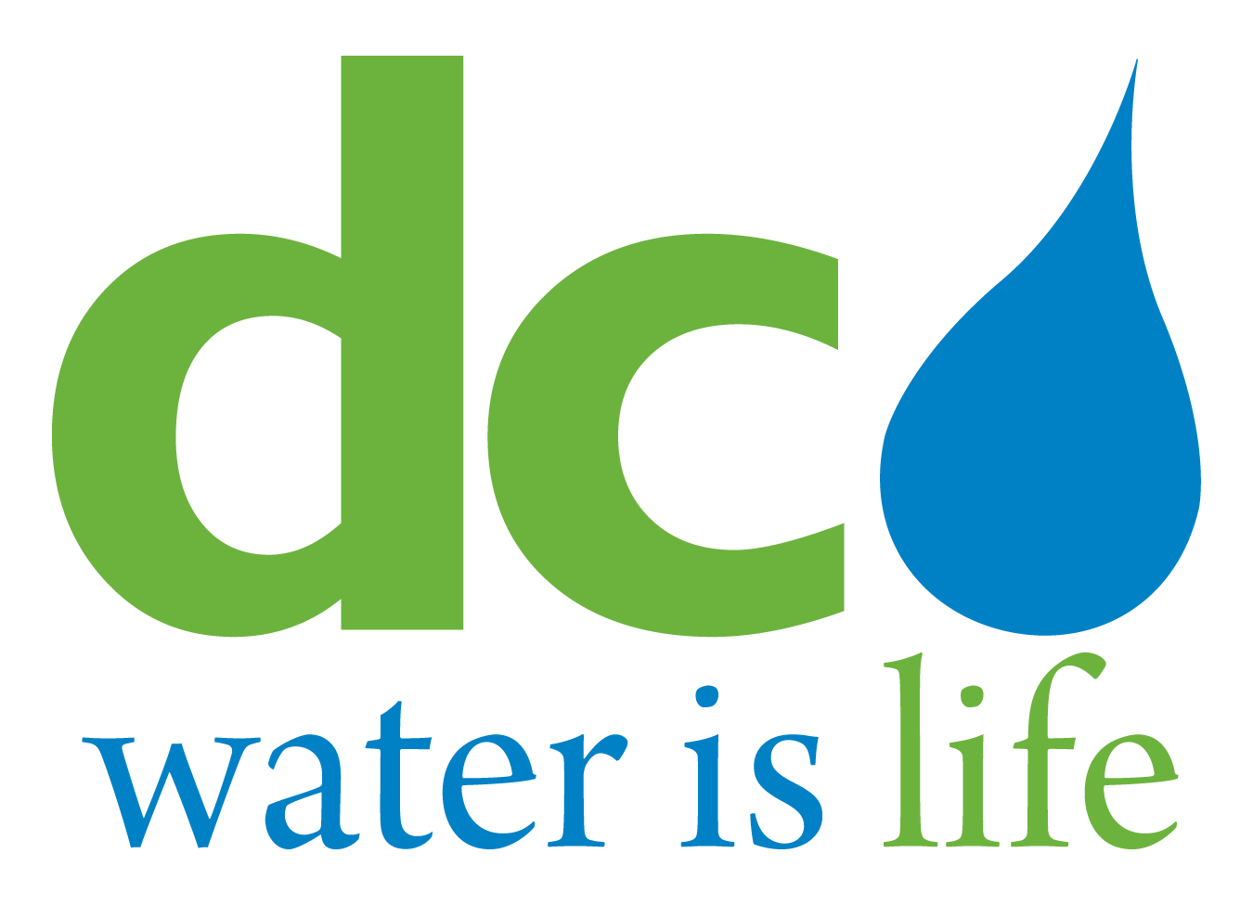

DISTRICT OF COLUMBIA WATER AND SEWER AUTHORITY

13th SPECIAL MEETING OF THE BOARD OF DIRECTORS

Thursday, May 24, 2018

10:15 a.m.

5000 Overlook Avenue, SW

(via conference call)

AGENDA

Call to Order (Chairman Tommy Wells)

- Roll Call (Linda Manley, Board Secretary)

lll. Executive Session (Chairman Tommy Wells)

lV. Adjournment (Chairman Tommy Wells)

1 The DC Water Board of Directors may go into executive session at this meeting pursuant to the District of Columbia Open Meetings Act of 2010, if such action is approved by a majority vote of the Board members who constitute a quorum to discuss: matters prohibited from public disclosure pursuant to a court order or law under D.C. Official Code § 2-575(b)(1); contract negotiations under D.C. Official Code § 2-575(b)(1); legal, confidential or privileged matters under D.C. Official Code § 2-575(b)(4); collective bargaining negotiations under D.C. Official Code § 2-575(b)(5); facility security under D.C. Official Code § 2-575(b)(8); disciplinary matters under D.C. Official Code § 2-575(b)(9); personnel matters under D.C. Official Code § 2-575(b)(10);proprietary matters under D.C. Official Code § 2-575(b)(11); decision in an adjudication action under D.C. Official Code § 2-575(b)(13); civil or criminal matters where disclosure to the public may harm the investigation under D.C. Official Code § 2-575(b)(14), and other matters provided in the Act.

