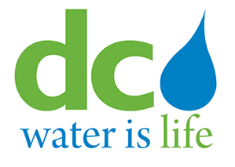
3rd Party Portal
Fire Hydrant Use

Quick Guide
For Users

Contents
Introduction 3
BPA User Role 4
1. Download 4
2. Registration 5
3. Perform transaction - Record Usage 12
4. Perform transactions – Report Damage 16

Introduction
The Third Party Portal (3PP) system provides a platform for 3rd party partners of DC Water and Food Service Establishments to record data, and to request and schedule activities to be performed by DC Water. DC Water staff can review and approve, reject or request additional information on transactions submitted by the 3rd party partners and FSE’s.
The system consists of the following modules or services for:
- Backflow Prevention Assembly Reporting
- Fire Hydrant Usage Reporting
- Grease Traps
- Sewer Service Tap Request
- Water Service Meter Set Requests

Each 3PP service listed above has 2 roles:
- Administrator (Admin) – this role is reserved for DC Water staff and supervisors
  - Admins are granted permission to use 3PP by a system administrator or another admin

- User – all 3rd party partners of DC Water fall into this role
  - All users must first register to use the 3PP system
  - After successfully registering to use 3PP, users must apply separately for each service they want to access

This Quick Guide addresses some of the basic functions performed by the user role for Fire Hydrant Usage.

Hydrant User Role
Hydrant Users must first register with a valid email account or address before requesting access to a service. After requesting access, users must upload relevant identification information, for review by DC Water staff. Applicants will receive email notifications on the status of their request. After registration is complete, you will be required to pass a short quiz on hydrant procedure to become a certified user. This certification lasts for 2 years.
- Download
- First, locate and open the “App Store” On your iPhone
- In the search bar, type in “3rd Party Portal” and hit search

- This page will show

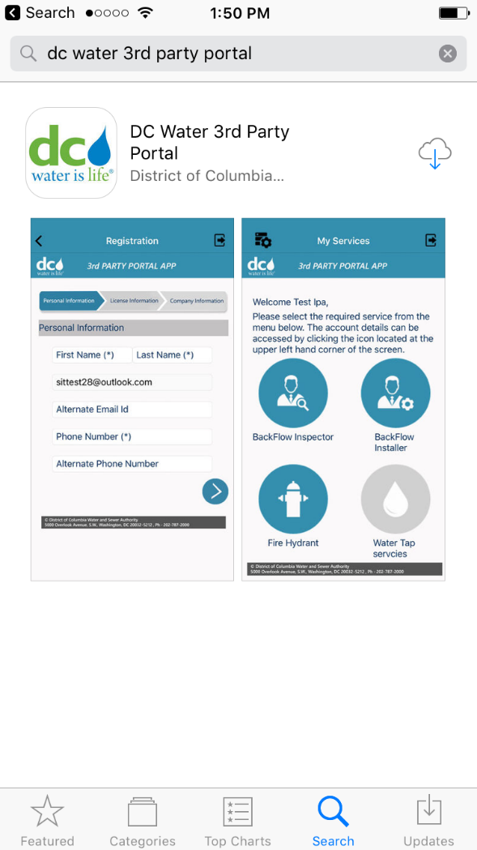

- Download “DC Water 3rd Party Portal”

Registration
- Open the “DC Water 3rd Party Portal application

Click “Sign In”

- This page will show

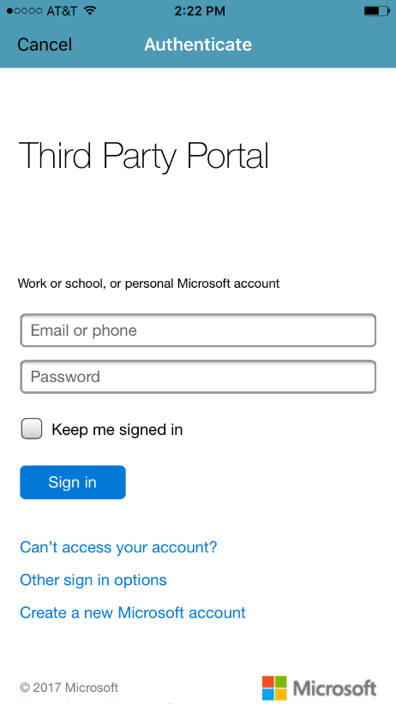

From this page, you will either register an email account, or create one and register it to use for this service

- There are three options for registering an email account for the service.

Option 1: Use a Microsoft email address (ending in hotmail.com or outlook.com) you already have.
If you already have a Microsoft email account and want to use it for this service, simply enter your account information (email and password) and follow the prompts. For the password, you can use the existing one or create a different one
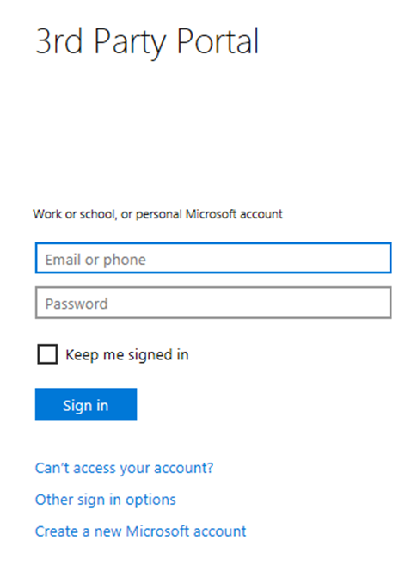
Enter your Microsoft email and password and Select “sign in”

The 3PP Registration page will show.

Option 2: Use a non-Microsoft email account. Typical non-Microsoft accounts are your company email, yahoo or Gmail account.

      - Select “Create a new Microsoft account”
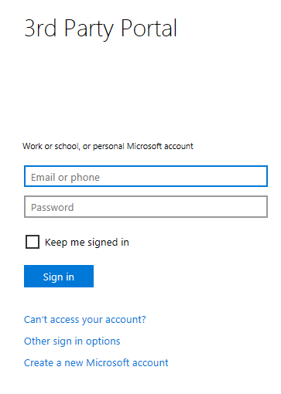

      - This page will show:

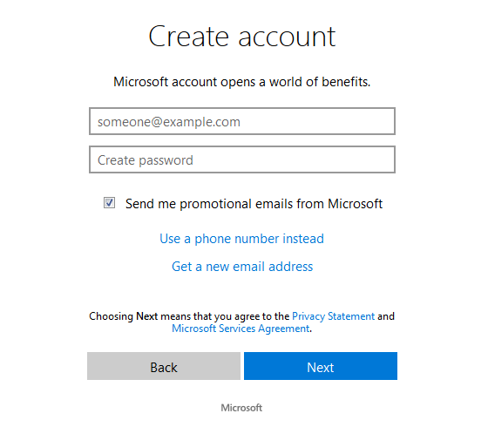

Enter your company email address (or other non-Microsoft email like a yahoo or Gmail account)
Create a password. It is recommended that the password you create should be different than the one you already have for that account
After you have chosen your password, select “Next”
Note: “uncheck” the box if you do not wish to receive promotional emails from Microsoft

      - A code will be sent to the email address that you listed above. After the code is sent to your account, enter it in the next screen, shown below, and select “Next”
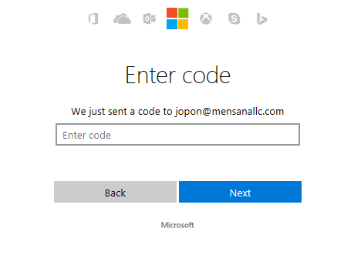

      - After you enter the security code from Microsoft and “Next”. This Permissions page will show:

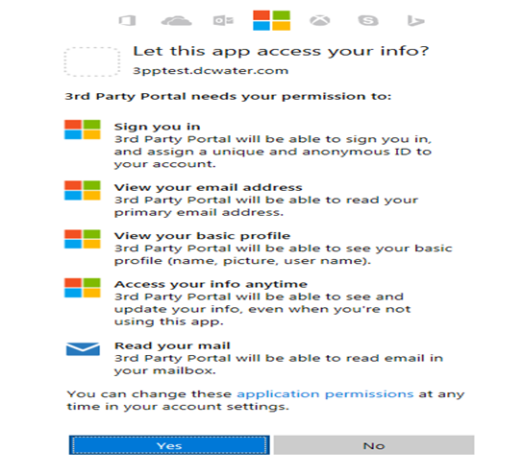
Review the permissions and select “Yes”, if you agree
      - The 3PP registration page will show.

Option 3: Create a new Microsoft (outlook) email address to use with this system.
Use this option if you do not want to use your existing Microsoft email account or you do not have an email account
- Select “Create a new Microsoft account”
- This page will show.
Select “Get a new email address”
- This page will show:
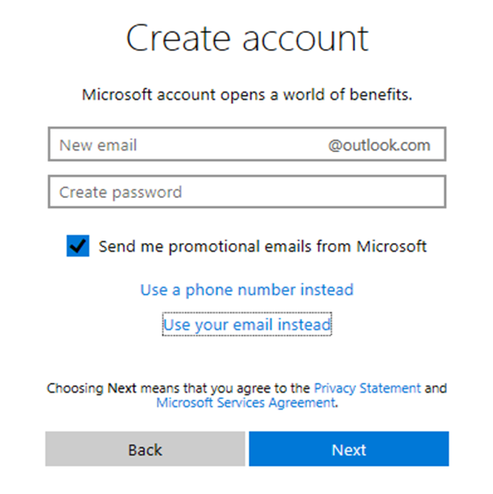

Enter the new email you want to use, create a password and select “Next”.

Note: “uncheck” the box if you do not wish to receive promotional emails from Microsoft

- This permissions page will show
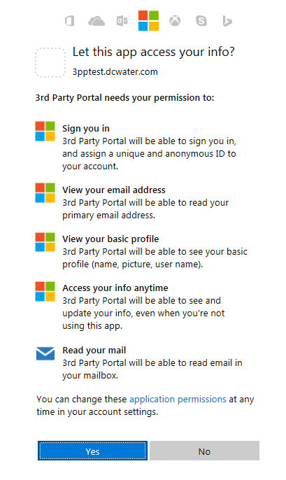
Review the permissions and select “Yes”, if you agree

- The 3pp Registration page will show.

- 3rd Party Portal Registration page. Fill out the fields. You must enter information in all the fields that are marked by an asterisk.

- Personal Information
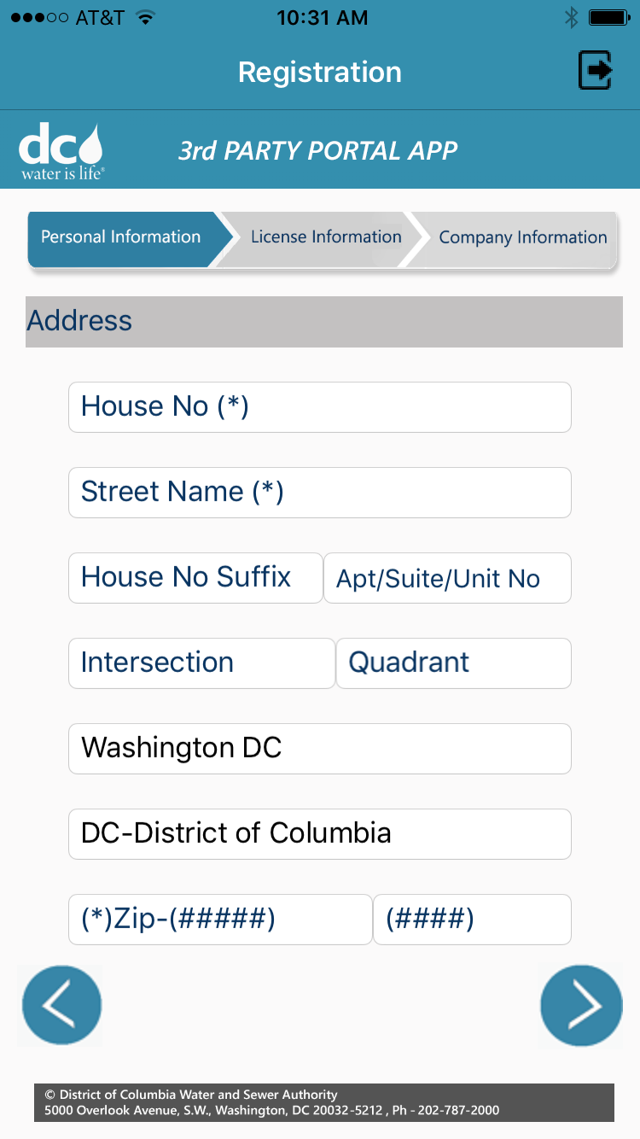
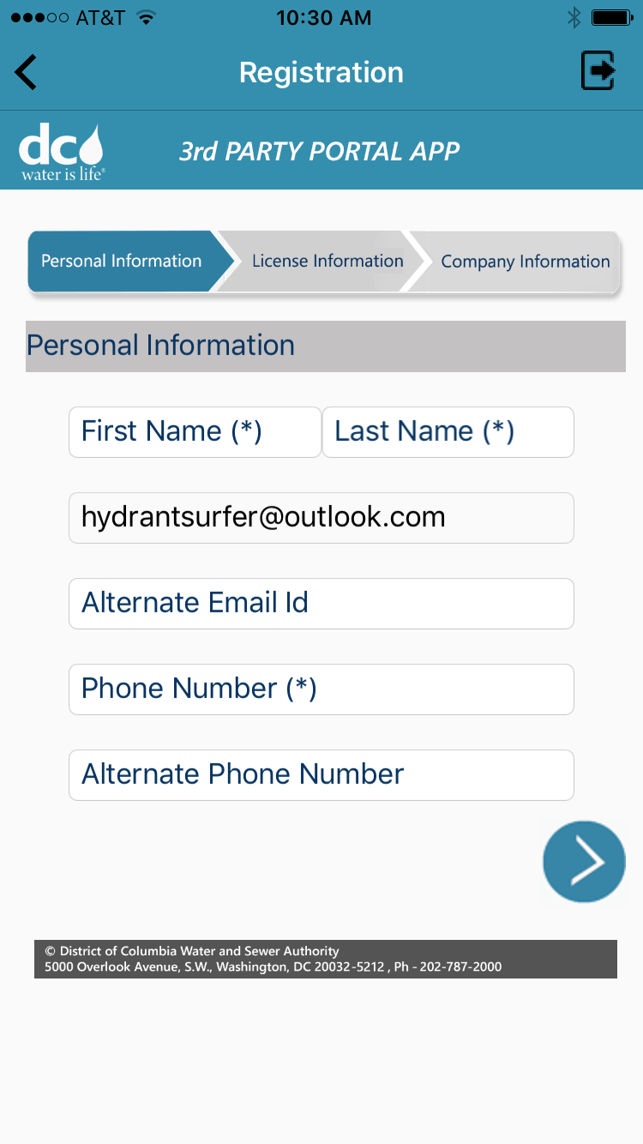

- License Information
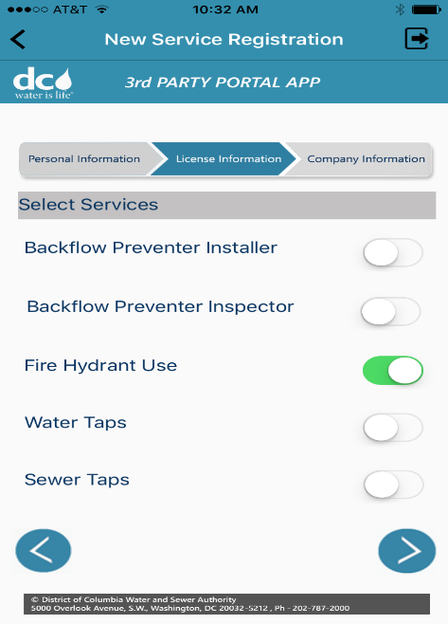
- Company Information
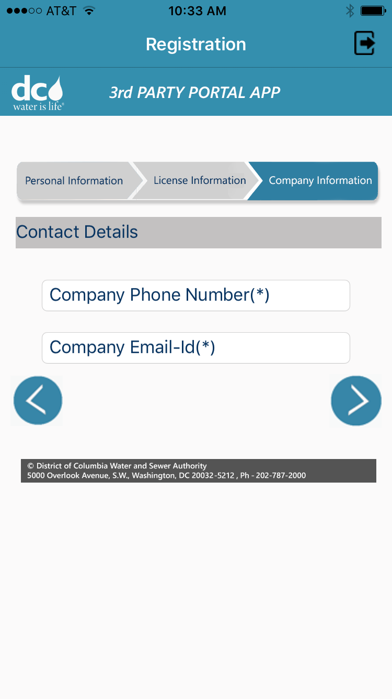
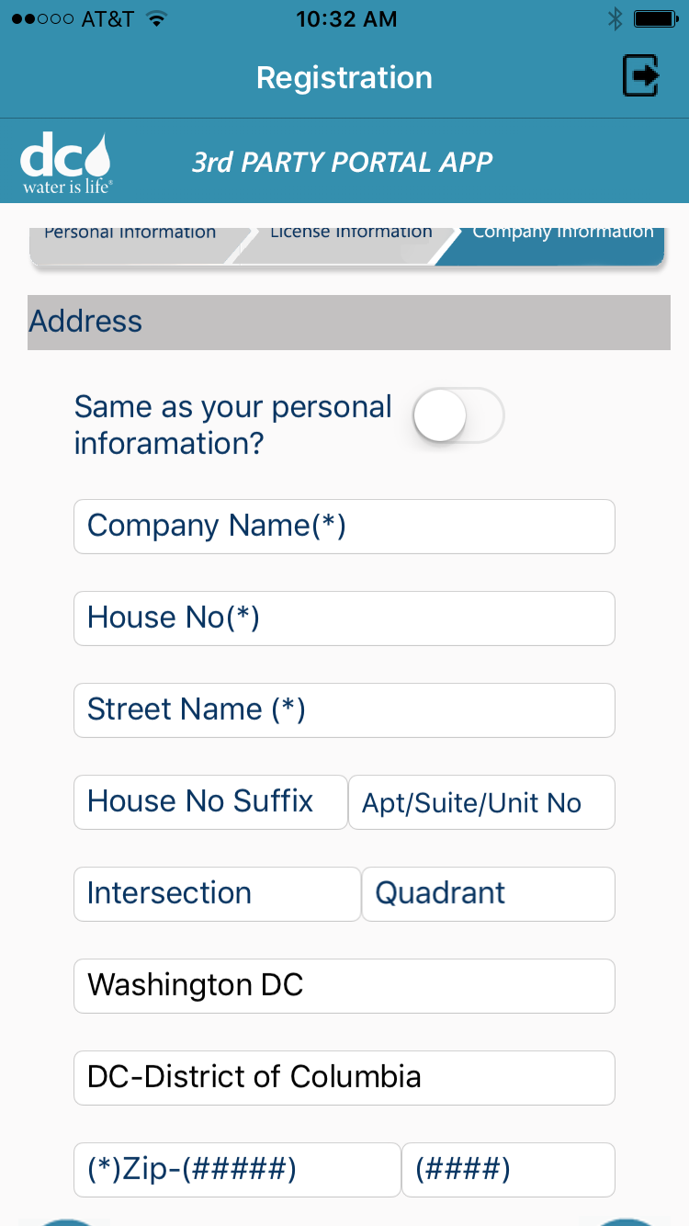

- Select “Review” to review and submit the application to DC Water.

Perform transaction - Record Usage

The User must have applied and been approved to use the system. The user must login with the email address used to register.

- Login and select “Fire Hydrant”
- Services you have been authorized to use are colored in.
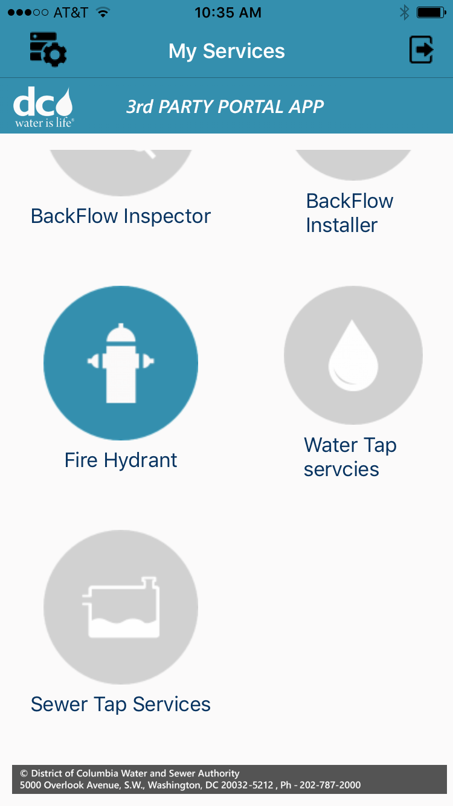
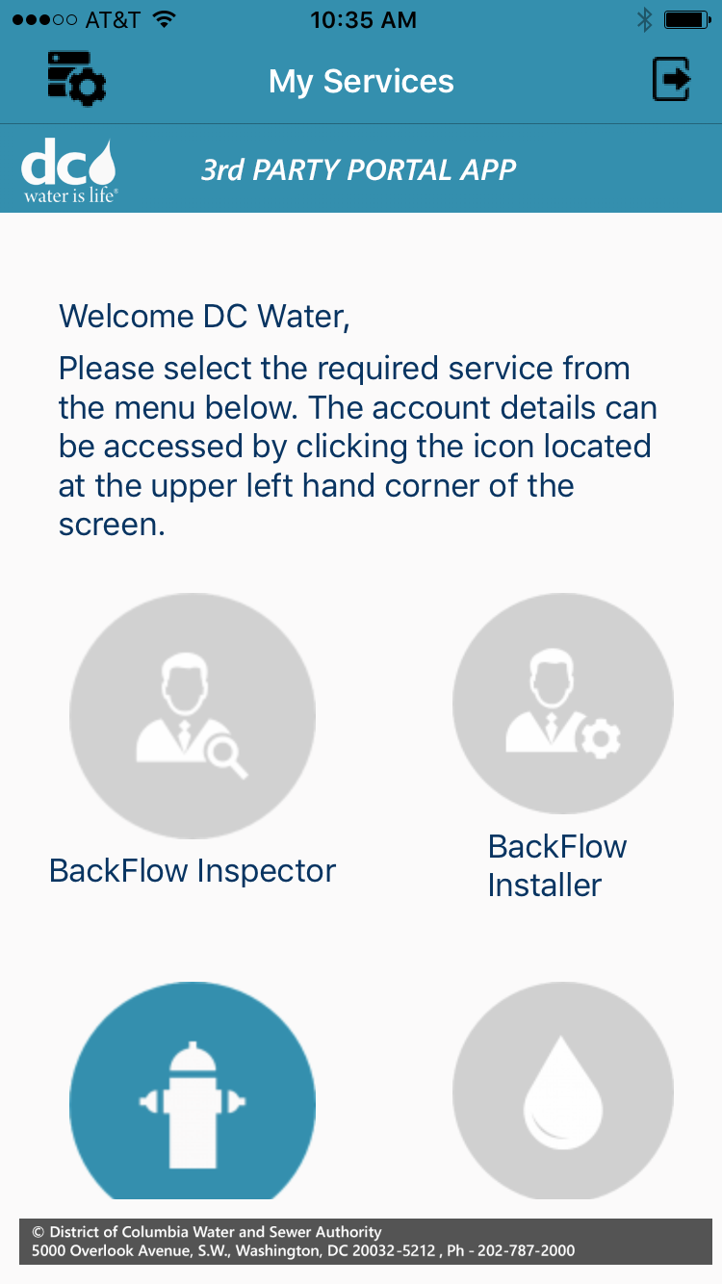

First time users will be required to take and pass a short quiz on fire hydrant safety and procedure
- Fire Hydrant Certification Test-
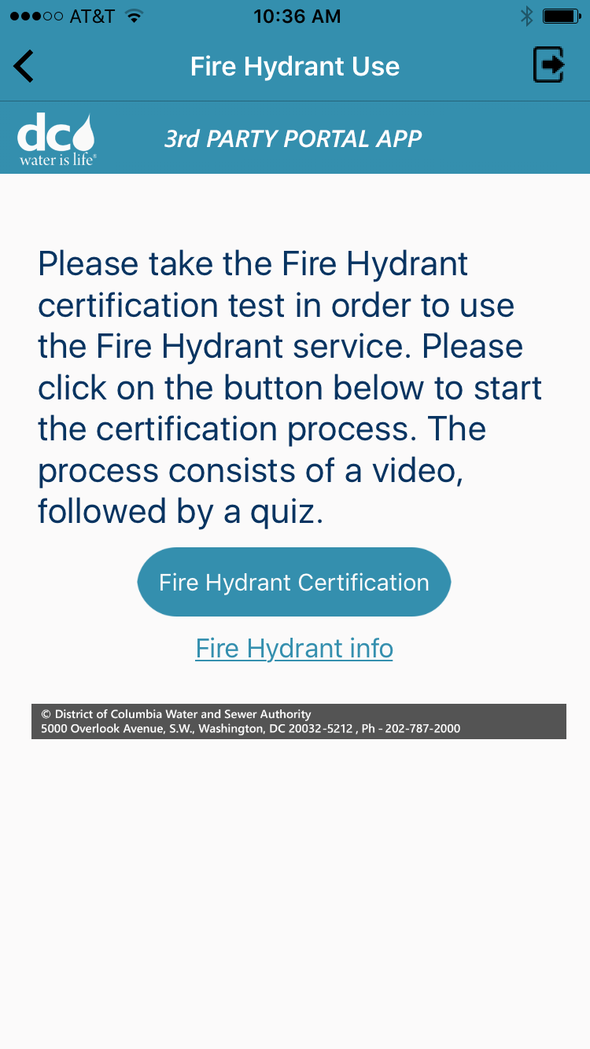

After the test is completed you will be taken to the fire hydrant service screen.

- Search - there are two ways to search for a hydrant, by permit/Hydrant Id or address

  - Search by permit/hydrant Id

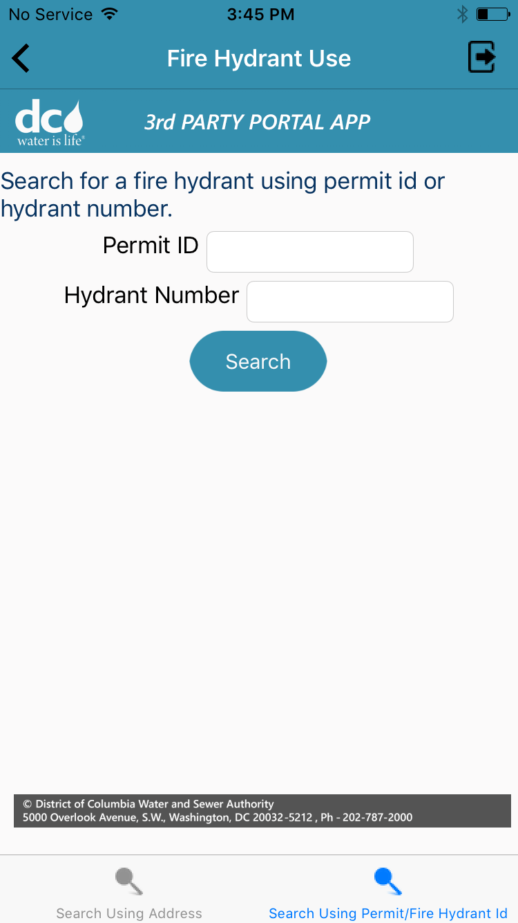

    - Enter your Permit ID number or the Hydrant number, then select “Search”

    - Select “Record Usage”, then enter your Permit No and select confirm.
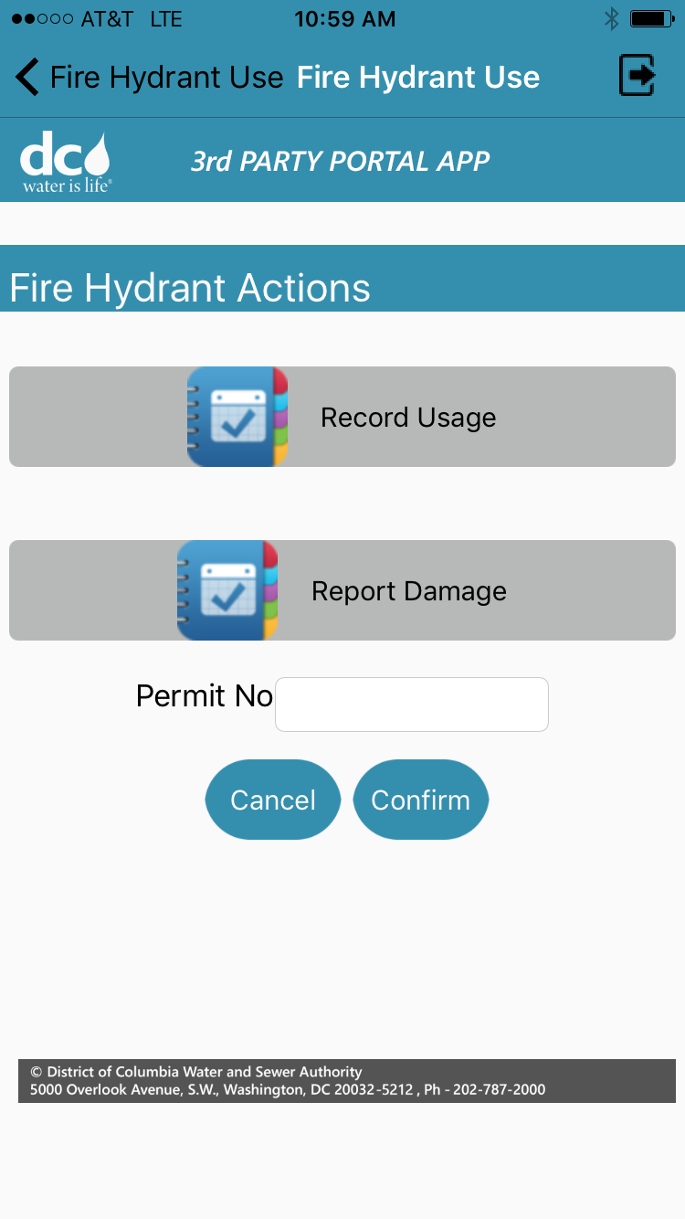

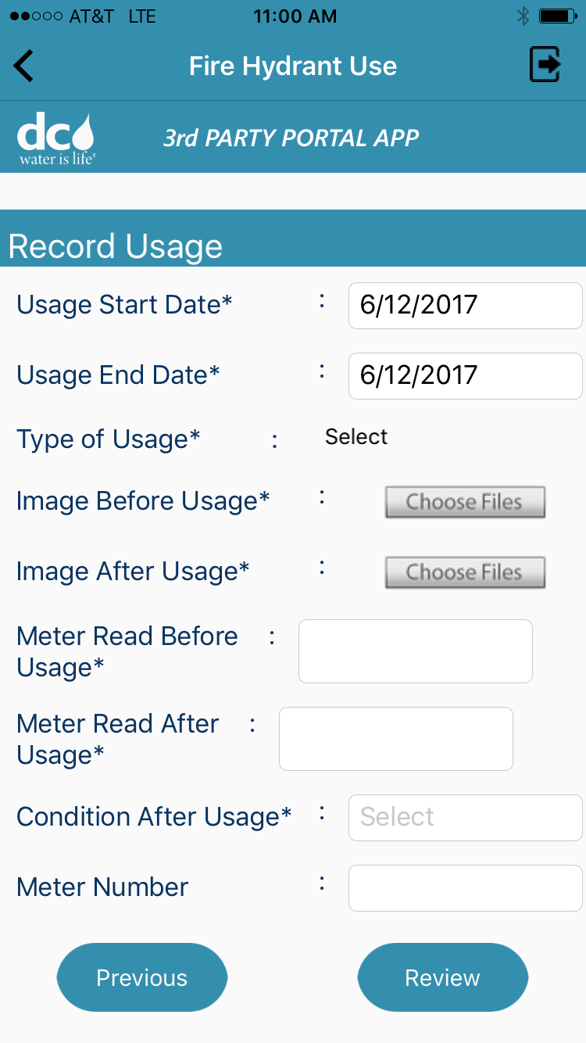

3. Enter all required fields and select review.

4. After you review and all fields are correct, select “confirm”.
5. After Fire Hydrant usage details have been submitted successfully, you will receive a transaction reference number.

  - Search by Address
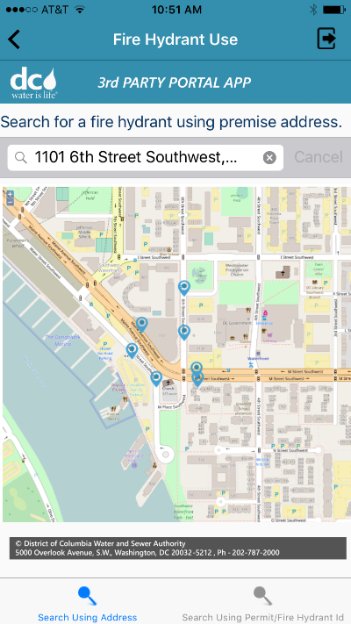
2. Select the hydrant that you would like to use on the map
- Insert the address into the search bar
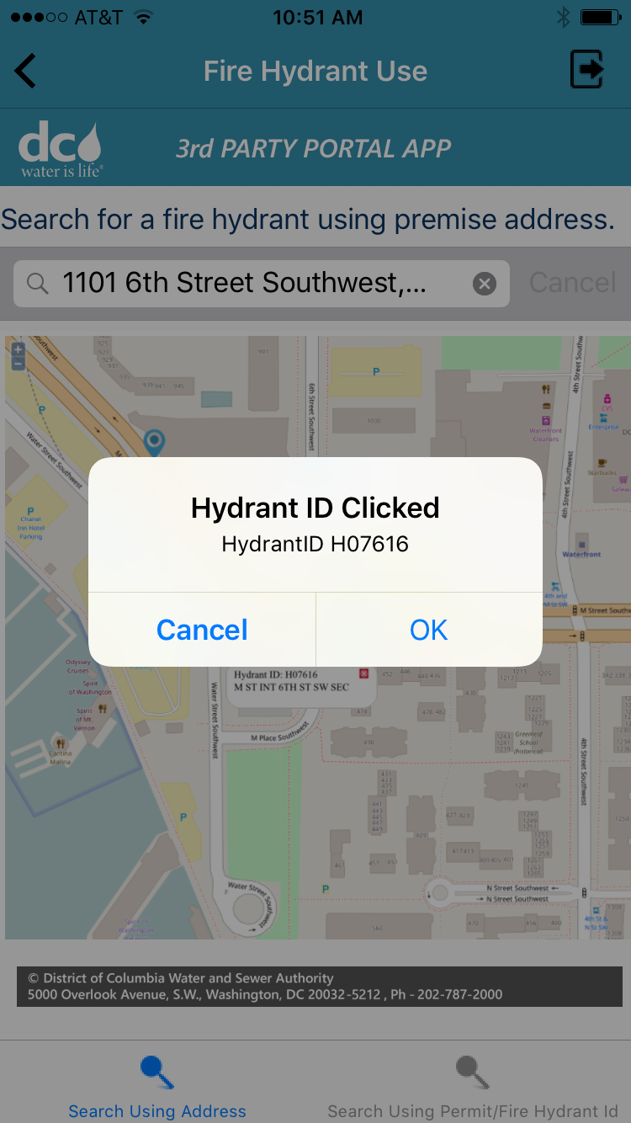

3. Select “Record Usage”, then enter your Permit No and select confirm.

4. Enter all required fields and select review.

Note: The numbers used for the before and after reading must show usage. The two numbers must be different.

5. Once you have reviewed and all fields are correct, select “confirm”.
6. After Fire Hydrant usage details have been submitted successfully, you will receive a transaction reference number.

Perform transactions – Report Damage

- Search - there are two ways to search for a hydrant, by permit/Hydrant Id or address

  - Search by permit/hydrant Id
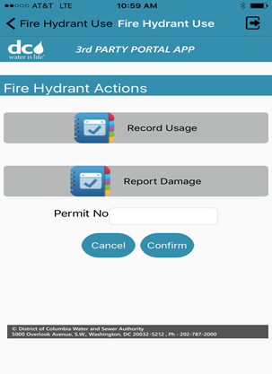

2. Select Report Damage
1. Enter your Permit ID number or the Hydrant number, then select “Search”

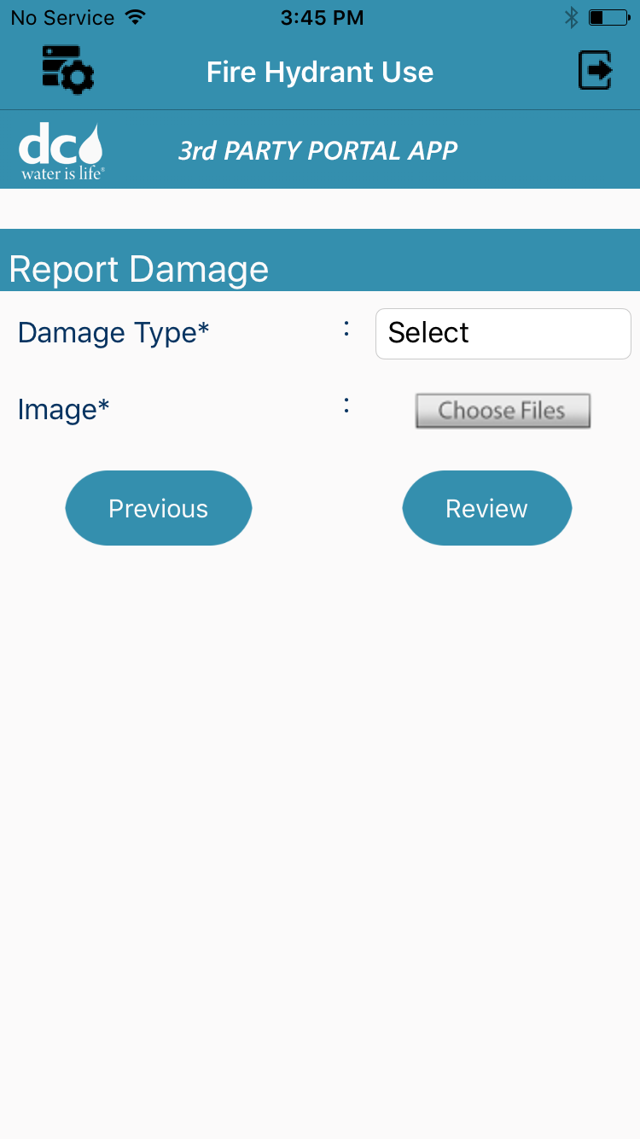

3. Identify the damage type from the drop down menu, then upload an image of the damaged hydrant

4. Review and submit the damage report. You will be given a transaction number

  - Search by Address
2. Select the hydrant that you would like to use on the map
1. Insert the address into the search bar

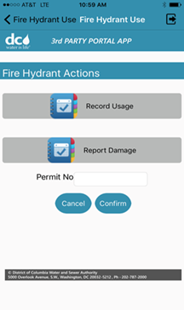 3. Select report damage

4. Identify the damage type from the drop down menu, then upload an image of the damaged hydrant

5. Review and submit the damage report. You will be given a transaction number

