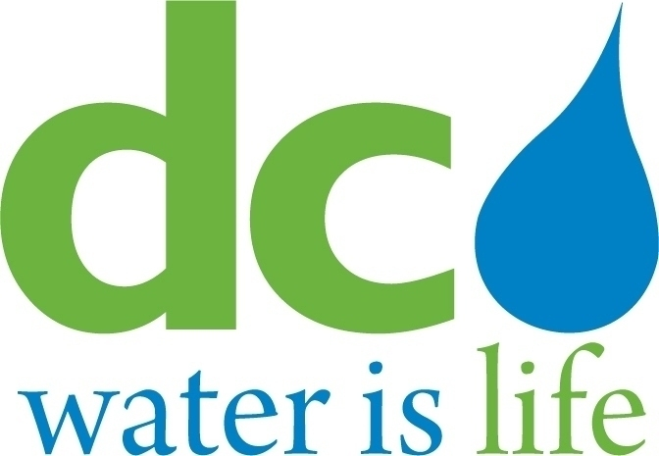

DISTRICT OF COLUMBIA
WATER AND SEWER AUTHORITY

Board of Directors

Human Resources and Labor Relations Committee

Wednesday, September 09, 2020
11:00 am
Join Microsoft Teams Meeting
202-753-6714 Conference ID: 670 663 162#

- Call to Order… ...............................................................…..Emile Thompson Chairperson

- Roll Call………………………………………………………….Linda Manley
Board Secretary

- Union Topics ........................................................................Union Presidents
Barry Carey, AFSCME 2091
Michelle Hunter, NAGE R3-06
Barbara Milton, AFGE 631
Jonathan Shanks, AFGE 872
Calvert Wilson, AFGE 2553

- Annual Leave: Use or Lose roll-over for Union members
- Benefits and Process changes affecting the terms and conditions of employment for Union employees-no prior notification to Union Presidents
- DC Water’s Cloud phone system (issues)
- Open Discussion

- Executive Session………………………………………………Emile Thompson
Chairperson

- Adjournment ..........................................................................Emile Thompson
Chairperson

