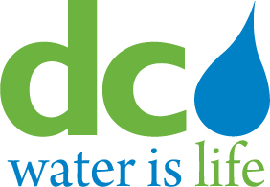
DISTRICT OF COLUMBIA
WATER AND SEWER AUTHORITY

Board of Directors

Special Meeting of the
Environmental Quality and Operations Committee

5000 Overlook Avenue, SW, Room 407

Wednesday, December 5, 2018
10:00 a.m.

I. Call to Order James Patteson Chairperson
10:00 a.m. II. Executive Session James Patteson

10:30 a.m. Ill. Action Item Thomas Kuczynski

10:35 a.m. lV. Adjournment James Patteson
Chairperson

* The DC Water Board of Directors may go into executive session at this meeting pursuant to the District of Columbia Open Meetings Act of 2010, if such action is approved by a majority vote of the Board members who constitute a quorum to discuss: matters prohibited from public disclosure pursuant to a court order or law under D.C. Official Code § 2-575(b)(1); contract negotiations under D.C. Official Code § 2-575(b)(1); legal, confidential or privileged matters under D.C. Official Code § 2-575(b)(4); collective bargaining negotiations under D.C. Official Code § 2-575(b)(5); facility security under D.C. Official Code § 2-575(b)(8); disciplinary matters under D.C. Official Code § 2-575(b)(9); personnel matters under D.C. Official Code § 2- 575(b)(10); proprietary matters under D.C. Official Code § 2-575(b)(11); decision in an adjudication action under D.C. Official Code § 2-575(b)(13); civil or criminal matters where disclosure to the public may harm the investigation under D.C. Official Code § 2-575(b)(14), and other matters provided in the Act.

