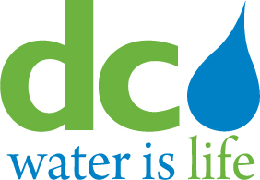
DISTRICT OF COLUMBIA
WATER AND SEWER AUTHORITY

Board of Directors

DC Retail Water and Sewer Rates Committee

Wednesday September 2, 2015

4:00pm

- Call to Order Alan Roth, Chairman

- Executive Session*

- Policy Memorandum for Final Amendment to WSRF (Attachment A) Mark Kim

- Action Item (Attachment B) Mark Kim
- (Action Item 1) Approval of Final Amendment for the Water System Replacement Fee
(effective October 1, 2015)

- Adjournment

* The DC Water Board of Directors may go into executive session at this meeting pursuant to the District of Columbia Open Meetings Act of 2010, if such action is approved by a majority vote of the Board members who constitute a quorum to discuss: legal, confidential or privileged matters under D.C. Official Code § 2-575(b)(4).

Follow-up-ITEMS – DC Retail Water and Sewer Rates Committee Meeting (August 25, 2015)

There were no follow-up items from the August 25, 2015 committee meeting

