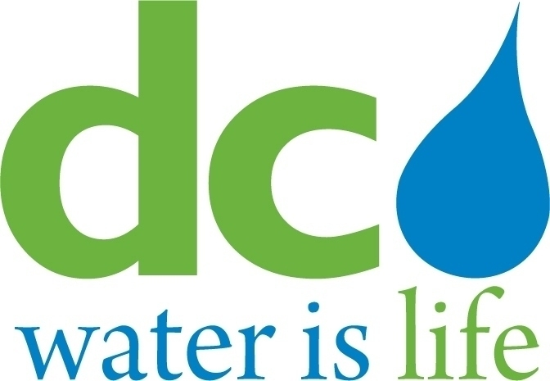

DISTRICT OF COLUMBIA
WATER AND SEWER AUTHORITY

Board of Directors

Nominating Committee

Monday, September 14, 2015
10:00 a.m.

- Call to Order………………………………………………………………………Timothy Firestine
Chairman

- Discussion/Recommendation – First Vice Chair and Second Vice Chair

- Adjournment…………………………………………………………………….. Timothy Firestine
Chairman

