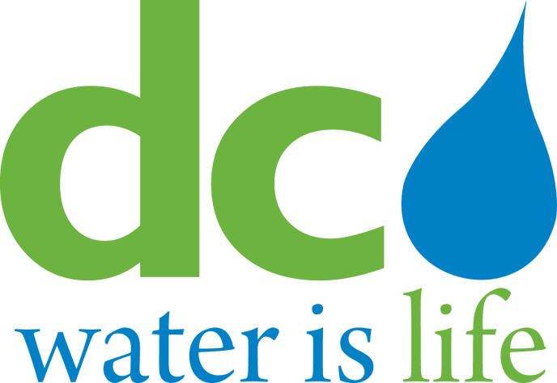

District of Columbia
Water and Sewer Authority

Board of Directors

Environmental Quality and Sewerage Services Committee
Thursday, July 16, 2015

9:30 a.m.

MEETING MINUTES

Committee Members Present DC Water Staff Present
Bo Menkiti, Acting Chairperson Biju George, Chief Operating Officer
David Lake Len Benson, Chief Engineer
James Patteson Meena Gowda, Principal Counsel
Matthew Brown Linda R. Manley, Secretary to the Board
Elizabeth Feldt
Howard Gibbs
Brenda Richardson (via phone)

- Call to Order

Mr. Bo Menkiti, Acting Chairperson, called the meeting to order at 9:43 AM.

AWTP Status Updates

BPAWTP Performance

Mr. Walt Bailey, Assistant General Manager for Wastewater Treatment, reported that the monthly average influent flow was 333 MGD, bringing the 12-month average to 290 MGD. 11.9-inches of precipitation fell during the June reporting period. Mr. Bailey noted that the new enhanced nitrogen removal facility is performing well, producing a low total nitrogen concentration of 2.8 mg/l. Overall, plant performance was excellent with 100% permit compliance. Biosolids production was 523 wet tons per day (wtpd).

Mr. Bailey reported that the Combined Heat and Power (CHP) facility is operating 2 turbines and at the end of June had produced 1,575 MWh of electricity for plant consumption. Mr. Bailey noted that some digester gas continued to be flared but expects all digester gas to be used once the third turbine is in operation. The committee requested the electricity usage chart to be updated to show the electricity production from CHP and the electricity purchased. Mr. Bailey responded that the bar chart will be modified for the coming months. Mr. Bailey noted that the design-build contract requires the CHP system to meet the performance guarantees during the operating period, which includes equipment maintenance and training of staff prior to receiving acceptance from DC Water.

updates: potomac interceptor sewer

1. Odor Abatement Project

Ms. Liliana Maldonado, DETS Director, reported that the failed valve actuator at Maryland Site 17 is being replaced and the site will be operational shortly. Site 27 (Old Angler’s Inn) new carbon media specifically designed to treat hydrogen sulfide (H2S) and dimethyl sulfide (DMS) odors will be delivered Monday, July 20, 2015 to replace the current carbon media. Site 27 odor control facility is expected to be back online the week of July 27, 2015. Virginia Site 31 started the operational demonstration test on July 16, 2015 and expects to have the required Fire Marshall approval to place the facility in full operation in early August 2015. Ms. Maldonado added that during her visit to the Potomac Interceptor Site 27 on July 16, 2015, the current carbon system was temporarily turned on and she noted the DMS odor could be perceived but was not overwhelming. Ms. Maldonado noted the entire system optimization and balancing is expected to start in August 2015 once all 7 odor control sites are in operation.

IV. ACTION ITEM - JOINT USE

None

ACTION ITEM – NON-JOINT USE

Contract No. 140050, SAK Construction, LLC

Mr. Len Benson, Chief Engineer, presented the action item1.

Action Item 1 is a request to execute a contract to rehabilitate sewers under buildings to increase system efficiency and add 50-year service life. The committee inquired to the significant difference in the bid amount of SAK and the two other bidders, and asked whether SAK had a history of submitting low bids in anticipation of change orders. Mr. Benson responded that SAK is considered a preferred contractor and did not have a history of underbidding.

The Committee will recommend the action item to the full Board.

V. OTHER BUSINESS/EMERGING ISSUES

None

VI. EXECUTIVE SESSION

The committee went into an executive session and reconvened at 10:33 a.m.

IX. ADJOURNMENT

The meeting was adjourned at 10:35am.
Follow-up Item

- Revise Blue Plains Electricity Usage bar chart to show electricity production from CHP and the electricity purchased.

