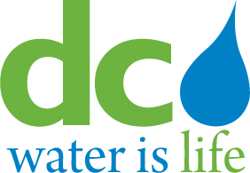
DISTRICT OF COLUMBIA

WATER AND SEWER AUTHORITY
BOARD OF DIRECTORS
Human Resources and Labor Relations Committee
July 9, 2014

MEETING MINUTES

Committee Members Present DC Water Staff Present
Edward L. Long, Chairman George Hawkins, General Manager
Robert L. Mallett Randy Hayman, General Counsel
Ellen Boardman Rick Green, Director, Human Capital Management
Keith Anderson Mustaafa Dozier, Director, Labor Relations
Rachna Butani Linda R. Manley, Board Secretary

1. Call to Order

Edward L. Long, Jr., Chairman, called the meeting to order at 11:30 am. There were no regularly scheduled discussion topics for this meeting. The committee proceeded in executive session.
2. Executive Session
Executive session commenced at 11:35 a.m., to address personnel matters pursuant to DC Official Code Section 2-(575(b)(10).

The executive session ended at 12:40 p.m.

The Committee reconvened into open session.

3. ACTION ITEM
The Committee is recommending the DC Water working condition agreement with AFGE
Local 631 to the full Board for approval at the September 4, 2014 meeting.

4. Adjournment
There was a motion to adjourn at 12:45 pm.

.

