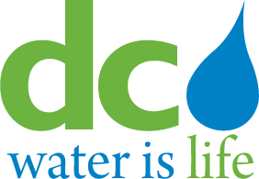
DISTRICT OF COLUMBIA

WATER AND SEWER AUTHORITY

BOARD OF DIRECTORS
Human Resources and Labor Relations Committee
April 10, 2014

MEETING MINUTES

Committee Members Present DC Water Staff Present
Rachna Butani George Hawkins, General Manager
Robert L. Mallett Randy Hayman, General Counsel
Edward L. Long, Jr. Rosalind Inge, (Acting) AGM, Support Svcs
Aubrey Thagard Linda R. Manley, Board Secretary

1. Call to Order

Edward L. Long, Jr., Chairman, called the meeting to order at 9:40 am. There were no regularly scheduled discussion topics for this meeting. The Committee proceeded in executive session.
2. Executive Session
Executive session commenced at 9:42 a.m., to address personnel matters pursuant to DC Official Code Section 2-(575(b)(10).

The executive session ended at 10:19 am.

3. ACTION ITEM

to The Committee supportsthe DC Water working condition agreement with AFSCME Local 2091 and recommend Board approval at the May 1, 2014 meeting.

4. Adjournment

There was a motion to adjourn at 10:22 am.

FOLLOWUP ITEM(S):

A request was made for Authority staff, at the July 9, 2014 meeting; make a presentation on the Authority’s workforce profile. Such a presentation should include information on employee demographics, the number of retirement age employees, and other relevant information regarding the composition of the Authority’s workforce.

