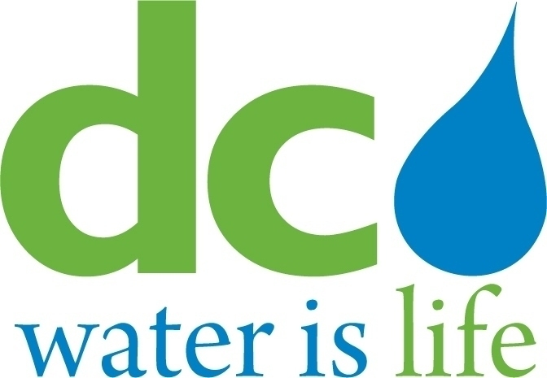

DISTRICT OF COLUMBIA
WATER AND SEWER AUTHORITY

Board of Directors

Human Resources and Labor Relations Committee

Wednesday, March 18, 2015
9:00 a.m.

- Call to Order Edward L. Long, Jr.
Chairman

- Union Topics ……………………………………………………………Union Presidents
Frank Walton, Secretary, AFSCME 2091
Michelle Hunter, NAGE R3-06
Barbara Milton, AFGE 631
Jonathan Shanks, AFGE 872
Charles White, AFGE 2553

- Early out Retirement for Civil Service employees with an option for part-time retirement.

- The Water and Sewer Department wants numerous employees to be certified, the concern is the District of Columbia does not have regulatory oversight of operator certification programs.

- Discuss DC Water requiring Commercial Driver’s License (CDL), where the job duties do not fit the requirement for a CDL. Is this requirement being used to put employees in a random drug testing pool?

- Safety concerns due to shortage in staff at the Sewer Pumping division and the Wastewater Treatment Department.

- Executive Session – To discuss personnel matters pursuant to D.C. Official Code Section 2-575(b)(10)…………………………………………………Edward L. Long, Jr.

- Adjournment…………………………………………………………Edward L. Long, Jr.

* The DC Water Board of Directors may go into executive session at this meeting pursuant to the District of Columbia Open Meetings Act of 2010, if such action is approved by a majority vote of the Board members who constitute a quorum to discuss: matters prohibited from public disclosure pursuant to a court order or law under D.C. Official Code § 2-575(b)(1); contract negotiations under D.C. Official Code § 2-575(b)(1); legal, confidential or privileged matters under D.C. Official Code § 2-575(b)(4); collective bargaining negotiations under D.C. Official Code § 2-575(b)(5); facility security under D.C. Official Code § 2-575(b)(8); disciplinary matters under D.C. Official Code § 2-575(b)(9); personnel matters under D.C. Official Code § 2-575(b)(10);proprietary matters under D.C. Official Code § 2-575(b)(11); decision in an adjudication action under D.C. Official Code § 2-575(b)(13); civil or criminal matters where disclosure to the public may harm the investigation under D.C. Official Code § 2-575(b)(14), and other matters provided in the Act.

