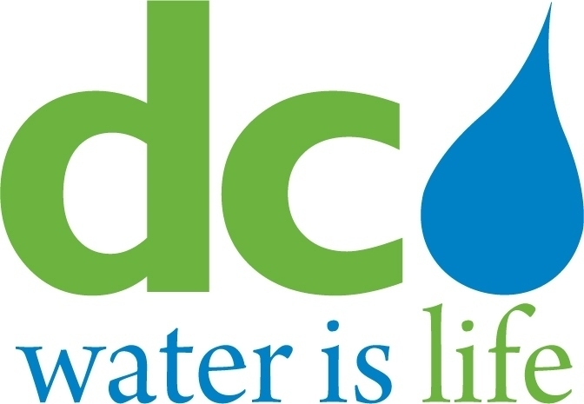
DISTRICT OF COLUMBIA

WATER AND SEWER
AUTHORITY

BOARD OF DIRECTORS

Governance Committee
September 10, 2014
9:00 a. m.

MEETING MINUTES

Committee Members DC Water Staff
Ellen Boardman, Chairperson George Hawkins, General Manager
Rachna Butani Randy Hayman, General Counsel
Edward Long Linda Manley, Board Secretary
Alan Roth

Chairperson Boardman convened the meeting at 9:05 a.m. The Chairperson turned the Committee’s attention to Agenda Item # 2 – Employment Programs Update. Katrina Wiggins, Chief of Staff, summarized the Workforce Hiring Pilot Program Initiative, in which Fort Myer Construction and Capital Paving are participating. Ms. Wiggins reviewed the Program’s two-tiered incentive: under Tier 1, a contractor will receive an incentive of 5% of the contractor’s DC residential payroll if the DC residential manhours are between 20% and 35% of total manhours; under Tier 2, a contractor will receive a 10% incentive when the DC resident man-hours are greater than 35%.

To date, Fort Myer Construction has used approximately 2,000of the 4,600 training hours available for this project.. At the start of the project, 11.6% of the Fort Myer workforce were DC residents; as of July 31, 2014 this figure had increased to 33.50%. The Committee asked how much the trainees in the Program were paid relative to the monies allocated to the Program. Ms. Wiggins advised that Fort Meyer was paid$35.00/trainee. The difference between that rate and the applicable prevailing rate for each worker was used by the contractors to provide special training that would not normally occur on a project. The Fort Myer project has not, as yet, used all the incentive funds set aside. A site visit occurred on May 9, 2014 and both the workers and contractors were interviewed. Fort Myer should discuss ongoing training expectations with the supervisors to ensure that training requirements are met.

Capitol Paving also had 4,600 training hours of which 1,166 hours had been performed to date. At the start of the project, 30.14 % of Capitol Paving’s workforce were DC residents. This figure had dropped to 26.91% by July 12, 2014. This drop was explained by the fact that more laborers are needed at certain times in the life of a project. Ms. Wiggins concluded that both projects will end without spending all their hiring funds. The contractors expressed interest in continuing the training programs.

Ms. Wiggins also reviewed the DC Water Greenroofs Project, which took place at Fort Reno with 10 trainees at the start. Eight graduated from the program, 3 of whom were subsequently employed by a project contractor. The Committee asked for a report on next steps for the Project. General Manager Hawkins advised that, while employees had been hired at the design/engineering level for green infrastructure, additional trainees would not be hired until a funding stream is created, which could occur if the proposed modification to the consent decree is approved Funds currently earmarked for subterranean tunnels and appurtenances would then be used to construct and maintain green infrastructure.

Ms. Wiggins turned the Committee’s attention to the 2014 DC Water Goods and Services Contracts’ employment data. These contracts are defined as “agreements whereby a contractor/consultant supplies a good (tangible product) time, effort and/or expertise.” Examples of services include janitorial services, security and fleet services. Of the 473 job positions in the Goods and Services Contracts, 57% (269 positions) are filled by residents of the user jurisdictions and 24% (114 positions) are filled by DC residents. There were 40 new hires on Goods and Services Contracts in 2014, of which 83% (33) were residents of user jurisdictions and 40% (16) were DC residents.

The employment data for both major construction projects and non–major construction projects were also reviewed. Of the 2,200 positions generated by the major construction projects, 43.3% (952) are residents of user jurisdictions; 9.4% (208) are DC residents; and 56.7 % (1,248) are residents outside the user jurisdictions. The non-major construction contracts generate 3,158 positions, of which 67% (2,135) are filled by residents of user jurisdictions; 13.7% (433) are DC residents); 13.% (431) are from other parts of MD.; 10.9 % (345) are from other parts of VA ; and 7.8 % (247) are outside DC., MD, and VA.

Data was also shared with the Committee showing the total number of new hires (18) reported by opportunity centers.

Data showing the 2014 MBE/WBE participation results was also presented to the Committee. A total of 26 active construction contracts were reviewed which revealed the total overall combined MBE participation to be 37% (goal 32%) and overall combined WBE participation to be 6% (goal 6%).

Chairperson Boardman requested that Randy Hayman, General Counsel, address Agenda Item # 3 - Discussion Regarding L S Caldwell & Associates’ DC Water Investigations. The Chairperson requested that upon the completion of the presentation in open session, the Committee, if needed, would conduct further discussions during executive session. Mr. Hayman reminded the Committee that the legal department had been requested to review for legal sufficiency, the investigative report and accompanying documents produced by L.S. Caldwell, and presented to the Committee July 9, 2014. This investigation covered allegations filed by employees working on three DC Water major projects. Mr. Hayman introduced Mr. Thomas Flaherty and Ms. Alexandra Romero from the Littler law firm. Mr. Flaherty proceeded to discuss each of the 20 allegations raised by the employees against the three DC Water subcontractors: Collins, Dominion Rebar and Lyn-Phill. The majority of the allegations concerned proper job classifications/wages, and safety issues. Mr. Flaherty concluded that the investigations, based upon the documents presented for review, were legally sufficient. The Committee thanked Mr. Flaherty and Ms. Romero
The Chairperson then turned to Agenda Item # 4 – Emerging Issues and Other Business. The General Manager raised the issue of micro- purchases and presented an analysis to the Committee. After summarizing the current micro-purchasing requirements, the Committee was informed that the level of effort to produce micro- purchase orders was disproportionately high compared to the small amount of spending they represented. The General Manager noted that according to the National Institute of Government Purchasing, the average micro-purchase threshold is $ 25,000.00.The recommendation was made to raise the micro-purchasing limit to $25,000.00. If adopted by the Board, the Office of Procurement will provide regular reviews and reports of purchasing activity to management. It was noted that the limit on the P-Card would not be raised at this time. The Committee recommended that the proposed increase for micro-purchases be forwarded to the full Board.

The Chairperson asked the Committee members if they had any emerging issues or other business to be discussed. Committee member Roth raised DC Water’s participation in a PEPCO rate case. He noted that while he appreciated the exhaustive response to his questions, he nevertheless respectfully disagreed with DC Water’s participation in the rate case.

Regarding Agenda Item # 5 - Agenda for Upcoming Committee Meeting – the Chairperson stated that a draft agenda would be generated and presented to the Committee members..

The Committee then went into Executive Session.
The Committee reconvened in Open Session. The Chairperson adjourned the meeting at 10:53 a.m.

