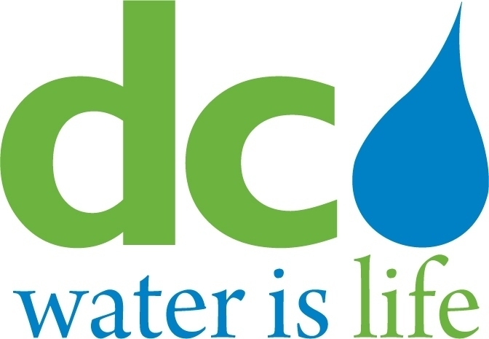
DISTRICT OF COLUMBIA

WATER AND SEWER
AUTHORITY

BOARD OF DIRECTORS

Governance Committee
November 12, 2014
9:00 a. m.

MEETING MINUTES

Committee Members DC Water Staff
Ellen Boardman, Chairperson George Hawkins, General Manager
Shirley Branch Randy Hayman, General Counsel
Rachna Butani Linda Manley, Board Secretary
Edward Long
Alan Roth

Chairperson Boardman convened the meeting at 9:04 a.m.

William Pickering, Government Relations Manager. addressed Agenda Item #2 – Government Affairs: Update. He noted that the FY15 federal budget remains in a Continuing Resolution that is set to expire on December 11, 2014. It is unclear if Congress will take up year-long appropriations measures between now and when the new Congress convenes in January, but a federal government shutdown seems unlikely. Mr. Pickering noted that DC Water’s FY15 federal payment for the Clean Rivers Project was not included in the bill that expires in December. The U.S. House included no funding for the Clean Rives Project in their proposed FY15 funding bill and the Senate proposed $16 million. Senate Democrats have been longstanding supporters of the clean Rivers Project. The shift to Republican leadership makes future appropriations for the project even more uncertain.

Mr. Pickering then turned to DC government matters. Council members Yvette Alexander (Ward 7), David Catania (At-Large), Kenyan McDuffie (Ward 5), Marion Barry (Ward 8), Jim Graham (Ward 1), and Tommy Wells (Ward 6) introduced the “Tenant Water Bill Notice Regulation Amendment Act of 2014” on June 3, 2014. The legislation attempts to amend the regulations governing DC Water to require the Authority to notify tenants when a lien has been placed on the property they inhabit due to unpaid DC Water bills. The bill was referred to the Committee on Transportation and the Environment, and a hearing has been scheduled for November 20th at 2 p.m. Government Affairs staff has communicated DC Water’s concerns with the bill to the DC Council. Specifically, DC Water’s customer service system is unable to identify when specific properties are occupied by tenants and the new requirement would trigger additional administrative costs. Mr. Pickering emphasized that DC Water staff feels confident it can work with the Council to improve the notification system to tenants before service is shut off.

The Chairperson turned the Committee’s attention to Agenda Item # 3 – DC Water Works! Employment Programs Update. Mr. Korey Gray, DC Water Compliance Officer summarized the two pilot projects being undertaken with Capitol Paving and Fort Myer. Mr. Gray explained to the Committee that the hourly rate for the four hires for the pilot was a combination of base rate plus the cost of training. A more detailed explanation of the breakdown will be offered at the next meeting. Mr, Gray noted that one employee in the Capitol Paving program is no longer with this program due to termination.. However, the other employee will be retained by Capitol Paving after the conclusion of the pilot program. Although Capitol Paving is trying to find a replacement for the terminated employee, this will be a difficult undertaking as it is late in the pilot program.

Mr. Gray then briefed the Committee on the status of Fort Myer’s pilot program. Both hires for this pilot program have remained in the program. Mr. Gray commented that the employees are now receiving both field and classroom training. Earlier it was discovered that the employees were only receiving field training but this has been remedied.

The Committee asked how the pilot programs were monitored by DC Water. Department of Engineering and Technical Services staff noted that every three months field interviews are conducted with both the employees and the contractors. The Committee expressed a concern with this level of monitoring and suggested that the level should be intensified. DC Water staff stated that they would come back to the Committee with the following information: (i) a breakdown of the overhead charge per hour; (ii) a review of the pilot program monitoring effort; and (iii) an explanation of the program’s curriculum and who is responsible for the curriculum.

Mr. Gray further briefed the Committee on FY 2014 contractor employment data. Mr. Gray noted that DC Water’s goods and services contracts generated 483 job positions, 58% of which were filled by residents within DC Water’s user jurisdictions and 24% of which were filled by District residents. The goods and services new hires totaled 40 of which 33 were residents of DC Water’s user jurisdictions. The DC Water non-major construction projects generated 3,158 positions of which 67% were filled by residents of DC Water’s user jurisdictions and 13.7% were filled by District residents. Non-major construction project new hires totaled 180, of which 129 were from DC Water’s user jurisdictions. DC Water’s major construction projects generated 2,777 positions, 46% of which were filled by residents of DC Water’s user jurisdictions and 11% were filled by District residents. Mr. Gray noted that a total of 21 new hires were recruited through DC Water’s opportunity centers. The Committee was informed that Anchor Construction Corporation and DC Water Works! Satellite job center held a targeted career fair in Ward 8 during which 89 residents were interviewed. DC Water and Anchor Construction are planning additional events including a ‘Women in Construction’ job fair to be held in the early spring.

The Chairperson then turned to Agenda Item # 4 – Organizational Structure. George Hawkins, General Manager, briefed the Committee on DC Water’s response to issues raised by the Board involving labor compliance and procurement issues. Mr. Hawkins has appointed Korey Gray as the Compliance Officer to report to the Governance Committee on DC Water’s hiring and training initiatives. Such reports will be independently verified as needed. The need for in-house labor law expertise will be addressed with the hiring of a labor lawyer within the General Counsel’s office. The need for a heightened focus on procurement governance and procurement regulations was addressed with the creation of a new position - Chief Procurement Officer. The Chief Procurement Officer will be responsible for procurement governance, rules, procedures and delegations; assessments and recommendations on best practices; and advice to the General Manager on procurement decisions. Mr. Hawkins advised that, after conducting a national search, he hired John Bosley for the position. Mr. Bosley held a position in the General Counsel’s Office and is well-equipped to serve as Chief Procurement Officer. The need for a heightened focus on operational performance and improvement will be addressed with the creation of the position of Chief Operating Officer to take the place of the Chief of Staff position. This position will be responsible for assessing and reviewing the performance of all parts of DC Water’s operations. This position will seek to improve operational productivity as well as identifying and providing recommendations for best practices in the industry. The Committee commended Mr. Hawkins on his plan. This prompted a separate brief discussion on DC Water’s overall succession planning. Mr. Hawkins and Ed Long, Chair of the Human Relations Committee, advised this was an ongoing process being done in conjunction with the Human Relations Committee.

The Chairperson then addressed Agenda Item # 5 - Emerging Issues and Other Business. The Chairperson stated that the review of proposed changes to the procurement manual regarding debarment and suspension had been completed and suggestions had been submitted to the General Counsel for review. These modifications would be reviewed with the Governance Committee at its January 2015 meeting.

The Chairperson asked Mr. Randy Hayman, General Counsel, if there was a need for an executive session and Mr. Hayman responded that one was not necessary.

The Chairperson adjourned the meeting at 10:35 a.m.

