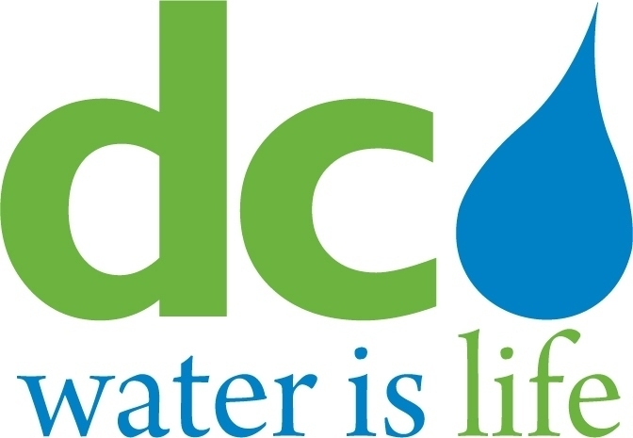
DISTRICT OF COLUMBIA

WATER AND SEWER
AUTHORITY

BOARD OF DIRECTORS

Governance Committee
May14, 2014
9:00 a.m.

MEETING MINUTES

Committee Members DC Water Staff
Ellen Boardman, Chairperson George Hawkins, General Manager
Rachna Butani Randy Hayman, General Counsel
Alan Roth Linda Manley, Board Secretary
Katrina Wiggins, Chief of Staff

Chairperson Boardman convened the meeting at 9:06 a.m. The Chairperson turned the Committee’s attention to Agenda Item # 2 (Government Affairs Update) and was informed that there were no updates at this time.

The Chairperson then moved to Agenda Item # 3 (Update on the Compliance Monitoring Program), presented by Loretta Caldwell. Ms. Caldwell advised that, from February to May 2014, MBE design costs planned and design costs awarded remained the same, as did WBE planned design costs. WBE design dollars awarded increased, as did MBE construction costs for both planned and construction dollars and WBE construction costs. WBE construction dollars awarded decreased as a result of a classification error.

Ms. Caldwell reviewed the employment statistics for major projects. From February to May 2014, the number of jobs filled by District of Columbia and User Jurisdiction residents increased with the exception of Prince George’s County. All DC Wards showed an increase in hiring during this time period except Ward 8, which showed no change from the prior period.

Ms. Caldwell then discussed the applicant and new hire statistics for both DC Water’s onsite and satellite job centers, both of which are generating much interest and traffic. Ms. Caldwell noted that, of those contractors reporting, one contractor, Ulliman Schutte, accounted for all new hires for the 1st and 2nd quarter to date. The Committee was informed that other contractors had hired DC residents but their information had not been supplied to Caldwell & Associates. This will be addressed in future reports.

Ms. Caldwell highlighted a successful recruitment effort by Chaney Enterprises for CDL drivers. The suggestion was made to target other specific skill sets in future job fairs. The Committee requested that the contractors inform DC Water about the efforts they are making to hire DC residents and requested Caldwell & Associates and staff to track all DC resident hiring activities including those contractors with union-represented employees.

The Chairperson then turned the Committee’s attention to Agenda Item # 4 (Update on the Workforce Development Program). Ms. Katrina Wiggins, Chief of Staff, updated the Committee on DC Water’s five active initiatives: (i) DC Water Works job centers; (ii) the Interim Employment Program; (iii) Pilot 1 (Workforce Hiring Program); (iv) Pilot 2 (the Workforce Training Program); and (v) Pilot 3 (Green Roof Training). Ms. Wiggins briefed the Committee on research undertaken on national best practices regarding local hiring initiatives. Approximately eighty local jurisdictions, public utilities and independent authorities were evaluated. This research was further broken down as follows: (i) the utilities that manage the top five water and wastewater facilities; (ii) the DC Water User Jurisdictions; (iii) the Washington Metropolitan Area; (iv) the top ten cities with highest unemployment; and (v) the ten states with highest unemployment.

For Pilot Program 1, Fort Myer and Capital Paving’s hiring percentages have been steady at 28-29 % resulting in the receipt of a 5% DC resident payroll incentive. For Pilot Program 2, Ms. Wiggins reported that trainees are receiving the required training. Further thought will be given to the trainees’ wage scales in relation to non-trainees, whether high school students should be considered for training, and whether a graduation ceremony should be held at the end of the training period. The Committee received encouraging news that both Capital Paving and Fort Meyer will be hiring all their trainees as full-time employees and both wish to continue with the training program.

Ms. Wiggins briefed the Committee on Pilot Program 3 (Green Roof Maintenance). There are currently ten trainees in the program and there will be ten in the Fall. The training will occur at DC Water’s Fort Reno site.

Mr. Randy Hayman, General Counsel, briefed the Committee on Agenda Item # 5 (Amendment to By-Laws to Provide for Rotating Vice-Chairs). The proposed amendment would provide that a member of each User Jurisdiction would hold a Vice-Chairperson position thus enabling each Vice-Chairperson, by virtue of an automatic upward rotation, to fill the Chairperson’s position temporarily in the event of the Chairperson’s absence (occasioned by a temporary absence or a vacancy). The nominating Committee would determine which jurisdiction representative would be First, Second, Third and Fourth Vice-Chairpersons. Mr. Hayman pointed out certain nuances of the amendments including: (i) Board members who hold an executive position in his/her jurisdiction will automatically be the Vice- Chairperson for that jurisdiction unless such member is the Chairperson in which case a non-executive shall be appointed to fill the Vice-Chairperson position; and (ii) in no event shall the positions of Chairperson and Vice-Chairperson be held by representatives from the same jurisdiction. The Committee discussed the proposed amendment at length noting that a First Vice-Chairperson filling the Chairperson position would be required to rotate down to the Fourth Vice-Chairperson position immediately following service in the event of the Chair’s absence or a vacancy, regardless of the length of such absence or vacancy. The Committee also noted that not every Board member holding a User Jurisdiction executive position may wish to be Chairperson as a result of time constraints. The Committee recommended referring these issues to the General Counsel for further study, thus deferring consideration of the item at the present time.

The Chairperson then turned to Agenda Item # 6 (Safety Standards at DC Water). Ms. Ayodele McClenney, Director of DC Water’s Occupational Safety and Health, addressed the Committee. Ms. McClenney first informed the Committee that DC Water as a public agency was not required to follow OSHA standards with the exception of the OSHA Directorate Whistleblower Protection Program. She further advised that DC Water’s safety regulations, policies and procedures meet and/or exceed OSHA standards and follow the consensus documents between OSHA and its partners, the American National Standards Institute (ANSI) and the members of the OSHA Alliance Program. One such example is DC Water’s procedures and requirements for the Confined Space Program exceed OSHA’s requirements. Similarly, DC Water’s Work Zone Safety Program is not required by OSHA; however, DC Water adopted DDOT’s standards. Another example of DC Water programs exceeding OSHA requirements is Hazard Communications. DC Water not only meets OSHA by performing training as required but exceeds OSHA by training all new employees in orientation.

Turning the Committee’s attention to safety complaints, Ms. McClenney noted that safety complaints are always investigated and may follow several paths including reporting complaints to supervisors, union officials, the Safety Office, the Union Management Safety Committee, and the Fraud and Abuse Hotline. Ms. McClenney gave an example of an employee who complained directly to the Safety Office. Specifically, the employee complained that an error had been made in the uniform he was issued as the fabric was too thin to protect his skin from chemicals. A thorough investigation followed resulting in the updating of uniform contract specifications for all affected employees.

The Chairperson noted that there are no Emerging Issues of note (see Agenda Item # 7) nor any Agenda Items for the July meeting at this time (see Agenda Item # 8). Regarding Agenda Item # 9 (see Executive Session), the General Counsel stated that an executive session was not necessary.

The Chairperson adjourned the meeting at 10:59 a.m.

