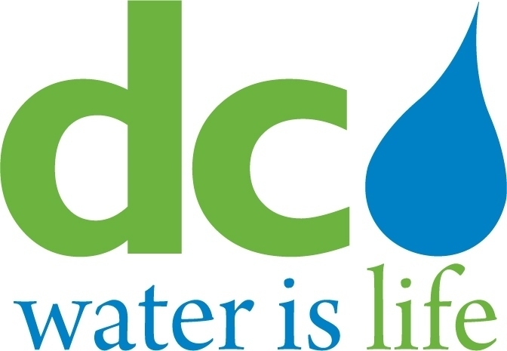
DISTRICT OF COLUMBIA

WATER AND SEWER
AUTHORITY

BOARD OF DIRECTORS

Governance Committee
July 9, 2014
9:00 a. m.

MEETING MINUTES

Committee Members DC Water Staff
Ellen Boardman, Chairperson Charles Kiely, Assistant General Manager
Rachna Butani Randy Hayman, General Counsel
Edward Long Linda Manley, Board Secretary
Alan Roth

Chairperson Boardman convened the meeting at 9:06 a.m. The Chairperson turned the Committee’s attention to Agenda Item # 2 (Government Affairs: Update). William Pickering, Government Relations Manager, first briefed the Committee on federal issues. The U.S. Senate Appropriations Subcommittee on Financial Services and General Government approved $16 million for the Clean Rivers Project in its Fiscal Year 2015 appropriations bill on June 24, 2014. This is the full amount requested by the President; however, the House Subcommittee markup provided no funding for the project in its bill. The House of Representatives Appropriations Subcommittee on the Interior also unveiled its EPA funding bill which includes a 30% cut to the Clean Water State Revolving Funds and a 16% reduction to the Drinking Water State Revolving Fund. The Senate has not yet taken action on its version of the spending bill.
Mr. Pickering noted that, once again, the Clean Rivers federal payment and EPA grant funding measures would likely be determined in Senate-House conference in the form of a large omnibus bill.

Mr. Pickering then turned to District issues. A potential bill regarding the notification of tenants concerning water and sewer bills was discussed. Mr. Pickering stated that Council staff was informed about DC Water’s inability to determine the identity of tenants; accordingly, staff appeared satisfied that such a bill was not feasible. Mr. Pickering concluded that the District’s 2015 budget had a provision for solar renewable energy which could prove beneficial to DC Water’s solar energy efforts.

Chairperson Boardman requested that Loretta Caldwell address Agenda Item # 3 (Update on the Compliance Monitoring Program). As the Committee had been briefed previously on the components of the Compliance Program, Ms. Caldwell turned the Committee’s attention to that part of the presentation showing DC Water’s performance in meeting its objectives. DC Water had an increase in both the MBE design costs awarded and the WBE design costs awarded from May 2014 to June 2014. There was also an increase in both MBE payments and WBE payments actually made from May 2014 to June 2014. Both the MBE and WBE construction costs awarded increased from May to June.

Ms. Caldwell then discussed the employment statistics for the major projects. From May to June, the number of jobs filled increased for the District as well the User Jurisdictions The Committee asked what percentage of job information was captured with online tracking. Ms. Caldwell stated that approximately 25% of the job statistics were not captured. She noted that at the time certain contracts were entered into, online reporting was not required. The Committee expressed concern about the amount of information not being captured. The Committee discussed whether the online reporting requirement could be included in such contracts at the time an option year or change order was executed. The General Counsel was asked to explore these possibilities. They also asked for information about hiring from contractors who obtained their workforce through union referrals. Ms. Caldwell continued her summary of employment statistics for major projects and pointed out that District Wards 1, 4, 5 and 7 had increases in hires from May to June.

Ms. Caldwell reported that there was a slight decrease in the percentage of apprenticeship hours by DC residents; however, there was an increase in the total number of apprenticeship hours. Ms. Caldwell’s report included a breakdown of cumulative jobs filled by state and cumulative jobs filled by category. Ms. Caldwell also discussed the number of applications received and interviews conducted at DC Water’s lead job center and satellite job centers. Ms Caldwell concluded her presentation with a job center success story. Through a collaborative effort between the Job Center and Mobile Dredging and Pumping Co., two DC residents became new hires on DC Water projects.

The Chairperson requested the General Counsel, Randy Hayman, to introduce Agenda Item # 4 (Summary of Investigation of Alleged Labor Issues on DC Water Projects). Mr. Hayman noted that of the 20 allegations made by ironworkers against three subcontractors on DC Water projects (Lyn-Phill Construction LLC, Collins Reinforcing, Inc., and Dominion Rebar, LLC), three had been substantiated and the seventeen remaining allegations had not been substantiated. Mr. Hayman then turned the remainder of the presentation over to Ms. Caldwell to discuss the investigation in detail. Ms. Caldwell first addressed the two phases of the investigation – Phase 1 which commenced on August 21 2012 and was comprised of wage investigations of Collins Reinforcing, Inc. for work performed on the ENR 1C Project. As a result of this investigation, the first compensation restitution for Collins workers occurred on April 26, 2013 resulting in a payment of $425,111.00 owed to 36 employees of Collins. Phase 2 of the investigation commenced on October 1, 2013 and was comprised of investigating allegations in 5 categories: payment of prevailing wages, safety, material theft, dangerous conditions and project accidents. Ms. Caldwell then reviewed the procedures followed during the investigation. The Committee asked the General Counsel to review the legal standards that were applied during the investigation to ensure that the conclusions were accurate. The General Counsel recommended, and the Committee agreed, to continue discussion of these legal issues in executive session. The Committee discussed with Ms. Caldwell the amount of time needed for these investigations. She advised that the investigation was a time-consuming process. She noted that some time was spent attempting to locate some of the workers who qualified for restitution checks so that payment could be made. Questions were asked about escrowing such monies pending location of missing workers. The General Counsel was asked to review what actions would be appropriate in the event a worker could not be located.

The Committee then addressed Agenda Item # 5 (Emerging Issues). A Committee member asked why DC Water had participated in an electrical rate hearing and what benefit that provided to the average DC Water customer given the relative cost of such participation (e.g., legal fees). The General Counsel advised that he would provide the requested information at the next Committee meeting.

The Chairperson noted that Agenda Item # 6 (Agenda for Upcoming Committee Meeting) is in the process of being developed and will be shared with the Committee members as appropriate.

The Chairperson then asked the General Counsel to assist the Committee with the proper procedures for going into Executive Session pursuant to Agenda Item # 7.

The Committee reconvened in Open Session. The General Council informed the Committee that the Office of General Counsel would review the documentation supporting the investigations’ conclusions to ensure legal sufficiency. The General Counsel will report these findings at the next Committee meeting.

The Chairperson adjourned the meeting at 11:37 a.m.

