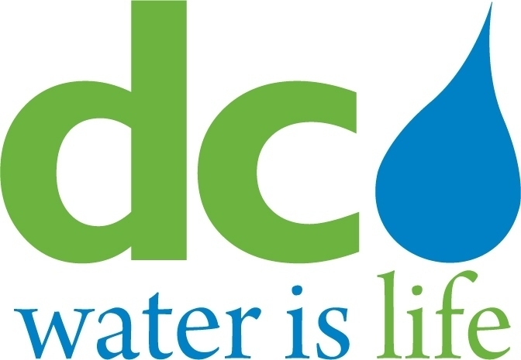
DISTRICT OF COLUMBIA

WATER AND SEWER
AUTHORITY

BOARD OF DIRECTORS

Governance Committee
January 8, 2014
9:00 a. m.
Meeting Minutes

Committee Members DC Water Staff
Ellen Boardman, Chairperson George Hawkins, General Manager
Rachna Butani Randy Hayman, General Counsel
Dawn Hawkins-Nixon Linda Manley, Board Secretary
Edward Long Katrina Wiggins, Chief of Staff
Alan Roth

Chairperson Ellen Boardman called the meeting to order at 9:04 a.m. The Chairperson took up Agenda Item # 2 – Update on the Compliance Monitoring Program. The Chairperson requested Ms. Loretta Caldwell of L S Caldwell and Associates to brief the Committee on this item. Ms. Caldwell first gave the Committee an overview of the compliance program for major projects. Ms. Caldwell then listed for the Committee those major projects that participated in the compliance program as well as those that were excluded from certain aspects of the program such as the fair share objectives. Ms. Caldwell pointed out that the total dollar value for the major projects covered by the program was $1,639,682,787.The fair share objectives for November 2013 and January 2014 were then discussed. Additionally, the MBE planned design costs subject to the objectives, the MBE design costs awarded, the WBE planned design costs subject to the objectives, and the WBE design costs awarded all showed an increase between November and January. Ms. Caldwell also advised that there was an increase for both MBE and WBE payments between November and January.

Ms. Caldwell then turned the Committee’s attention to construction dollars. While the total construction dollars subject to MBE fair share objectives increased between November 2013 and January 2014, the amount of construction dollars awarded subject to MBE fair share objectives decreased very slightly between November 2013 and January 2014. Regarding WBE fair share objectives, however, both the amount of construction costs planned and the construction costs awarded increased from November 2013 to January 2014. Ms. Caldwell also advised that both MBE and WBE payments had increased from November 2013 to January 2014. Ms. Caldwell noted that DC Water has always exceeded its fair share objectives.

Ms. Caldwell then turned the Committee’s attention to the employment statistics for major projects. The cumulative total for contractor employees on major projects was first discussed. The figures showed that from November 2013 to January 2014 the overall number of District of Columbia residents, and User Jurisdiction residents had increased while the overall number of Outside of User Jurisdictions residents had decreased. All Wards had increased from November 2013 to January 2014 with the exception of Wards 2 and 3. The figures for all other jurisdictions showed that the number of employees from Maryland and Virginia (not including the User Jurisdictions) increased from November 2013 to January 2014. The Committee asked if there was a way to insure that numbers were not duplicated. Ms. Caldwell pointed out that the software used automatically threw out duplications. The discussion on employment statistics continued with a look at employment by job category. (These figures were reflective of August 2013.) The majority of the employees were classified as laborers, with managers showing a slight increase over professionals. Ms. Caldwell then discussed the applicant and new hire statistics for both DC Water’s onsite and satellite job centers. The statistics showed that, while the on-site job center showed more applicant and hiring activity, the newly operational satellite job centers generated much interest and traffic. Ms. Caldwell summarized the job center portion of the presentation by listing the activities undertaken at the centers: (i) continual database expansion; (ii) a ‘contractor’s’ weekly bulletin; (iii) production of a contractor needs analysis; (iv) continuing training resource outreach efforts;(v) conducting contractor roundtable discussions; (vi) creating employment opportunity listings; and (vii) holding open house events.

The Chairperson then turned the Committee’s attention to Agenda Item # 3 – Update on the Workforce Development Program. Ms. Katrina Wiggins, Chief of Staff, gave the Committee an update on DC Water’s Permanent Workforce Employment
Program entitled ‘DC Water Works! Ms. Wiggins stated that the 12 month program to enact the DC Water Works! Permanent Workforce Employment Program would culminate in a comprehensive employment program for DC Water. Ms. Wiggins emphasized that the permanent employment program was designed to: (i) implement a world class employment program for DC Water ;(ii) incorporate best employment initiatives from around the country; (iii) increase local hiring across User Jurisdictions; (iv) focus on the District of Columbia; (v) institute universal employment and reporting requirements for all DC Water contractors; (vi) encourage growth of both short and long-term employment opportunities; and (vii) support the training of local residents towards self -sufficiency and permanent employment. Ms. Wiggins then gave a status update on the program, reminding the Committee that an interim employment program was currently in place. Ms. Wiggins then detailed the accomplishments of the interim program: (i) developed special provisions contract language for service contracts; (ii) conducted training for online utilization for the DC Water Procurement Department; (iii) conducted online system training to non–major contractors; (iv) conducted best practices research and analysis of employment program models for utilities, independent authorities and local jurisdictions; (v) conducted ongoing analyses on employment practices such as first source programs, apprenticeship program development, and workforce development strategies; and (vi) further conducted a legal analysis of the implications of implementing local hiring practices.

The Chairperson referred the Committee to Agenda Item # 4 - Update on Corinthian Contractors Charges. Mr. Randy Hayman, General Counsel, referred the Committee to the update they had received in their packet and noted that the matter would be further discussed in executive session.

The Chairperson then turned the Committee’s attention to Agenda Item # 5 – The Status of Investigations Regarding Ironworkers Labor Issues. Ms. Katherine Cahill of the General Counsel’s Office and Ms. Loretta Caldwell of L S Caldwell and Associates briefed the Committee on this issue. Ms. Cahill gave an overview of the matter and Ms. Caldwell discussed the specifics of the investigation. Ms. Cahill reminded the Committee that the matter was initially raised by an email dated September 24, 2013 from Ms. Fani–Gonzalez of the Matea Group to the District of Columbia Counsel listing numerous alleged labor abuses by three subcontractors working on DC Water major projects. This email was forwarded to DC Water. L S Caldwell and Associates was immediately tasked with investigating the allegations. Subsequently, Congressperson Eleanor Holmes–Norton sent a letter on November 6, 2013 to DC Water detailing her meeting with the DC Ironworkers Movement for Justice. This meeting also set out the allegations earlier stated in the previously mentioned email. DC Water responded to both the email and the letter from Congressperson Eleanor Holmes- Norton stating that DC Water took such allegations very seriously and that an investigation was already underway. The Committee was further informed of the DC Water projects involved, the named subcontractors performing work on the DC Water projects that were subject to the allegations, their prime contractors, and the dollar amount of the prime and subcontractor contracts. The Committee was briefed on the nature of the labor allegations against the subcontractors. These allegations included violations of the federal prevailing wage rates, safety violations, failure to provide required safety training, the fraudulent use of materials and the failure to follow the requirements of the District of Columbia First Source Act.

Ms. Caldwell then briefed the Committee on the investigatory process itself. The process included the following actions: (i) collect and review data from all sources; (ii) provide complainants with reasonable opportunity to present evidence and call witnesses; (iii) interview all individuals having information relevant to the investigation;(iv) pursue all significant issues relevant to the investigation, including evidence of any additional instances of possible misconduct; and (v) continue the investigation to completion. Ms. Caldwell also updated the Committee on the status of the ongoing investigation. The investigation included: (i) the review of certified payrolls; (ii) research pertaining to DC Water’s Construction Safety and Health Manual; and (iii) requests for documentation on initial employee safety orientations and attendance at monthly all-hands safety meetings.

The Chairperson then turned the Committee’s attention to Agenda Item # 6 - DC Water Process for Addressing Labor Complaints on DC Water Projects. The Chairperson requested that Ms. Katy Chang, Acting Director of Procurement, brief the Committee on this item. Ms. Chang suggested that she give an overview of the process and that she would drill down on a matter at the request of the Committee. The Committee concurred. Ms. Chang informed the Committee that DC Water’s Compliance Program incorporated federal Davis Bacon Act requirements, District of Columbia First Source Agreement requirements, and combined federal and local apprenticeship requirements.
Ms. Chang then briefed the Committee on these requirements. After the briefing the Committee asked Ms. Chang what criteria DC Water used to determine whether a contractor was a ‘responsible bidder’ as set forth in the DC Water procurement rules and procedures. Ms. Chang stated that DC Water Procurement followed industry standards. A discussion of the determination of what constituted a ‘responsible bidder’ ensued. The General Manager stated that DC Water’s goal was to have a ‘defensibly high standard to ensure that accountability is a DC Water hallmark.’

The Chairperson then discussed Agenda Item # 7 – Emerging Issues. As no issues were raised by the Committee, the Chairperson then turned the Committee’s attention to Agenda Item # 8 - Agenda for Upcoming Agenda Meeting. The
Chairperson then turned to Agenda Item # 9 – Executive Session. The General Counsel followed the appropriate protocol to allow the Committee to go into executive session to discuss Corinthian Contractor Charges.

Upon the conclusion of the executive session, the Chairperson went back to open session and adjourned the meeting at 11:40 a.m.

