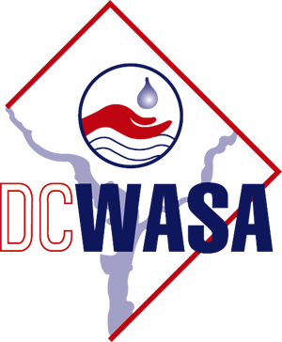
DISTRICT OF COLUMBIA
WATER AND SEWER AUTHORITY

Board of Directors

Customer and Community Services Committee

Tuesday, September 18, 2007
810 First Street, N.E.
11th Floor Conference Rm
11:00 a.m. - 1:00 p.m.

1. Call to Order…………….…………………………Alan Roth, Chairperson

11:00 a.m. 2. WASA Permit Process ………………..………………………..Johnnie Hemphill

11:25 a.m. 3. Public Affairs…………………………………..…Michele Quander Collins
- Monthly Report/Update
- Draft Communications Policy

11:45 a.m. 4. Customer Service………………………….…..Eva Liggins/Charles Kiely
  - Monthly Report/Update
  - Large Customer Outreach
- Customer Service Emergency Call/Response Improvements
- Hearing Officer Update …………….………………...Avis Russell

12:15 p.m. 5. Government Relations..........................................................Gordon Fry
- Monthly Report/Update

12:25 p.m. 6. CCSC Workplan Update

12:45 p.m. 7. Adjournment

