.
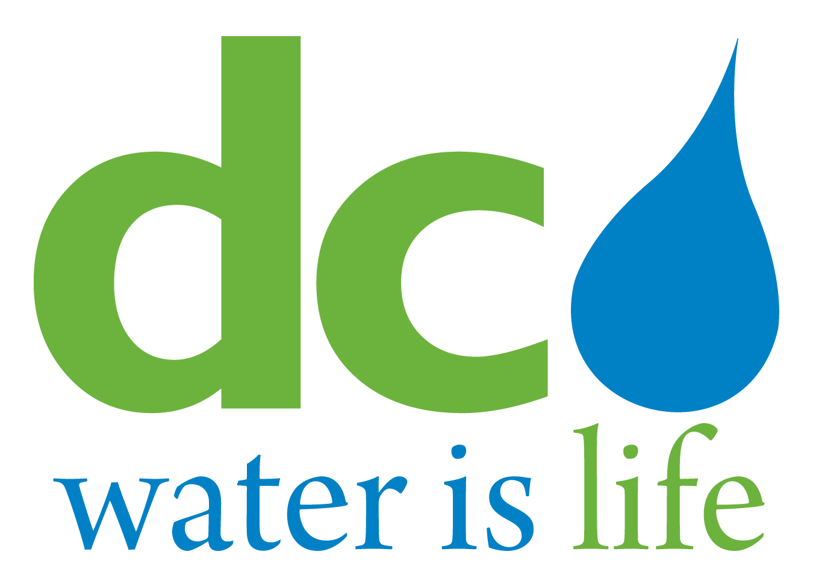

DISTRICT OF COLUMBIA WATER AND SEWER AUTHORITY

10th SPECIAL MEETING OF THE BOARD OF DIRECTORS

Tuesday, December 16, 2014

4:00 p.m.

5000 Overlook Avenue, SW

Room 407

(via conference call)

AGENDA

Call to Order (Chairman Allen Lew)

- Roll Call (Linda Manley, Board Secretary)

lll. Executive Session – To discuss legal, confidential and privileged matters pursuant to
Section 2-575(b) of the D.C. Official Code¹

lV. Adjournment

1 The DC Water Board of Directors may go into executive session at this meeting pursuant to the District of Columbia Open Meetings Act of 2010, if such action is approved by a majority vote of the Board members who constitute a quorum to discuss: matters prohibited from public disclosure pursuant to a court order or law under D.C. Official Code § 2-575(b)(1); contract negotiations under D.C. Official Code § 2-575(b)(1); legal, confidential or privileged matters under D.C. Official Code § 2-575(b)(4); collective bargaining negotiations under D.C. Official Code § 2-575(b)(5); facility security under D.C. Official Code § 2-575(b)(8); disciplinary matters under D.C. Official Code § 2-575(b)(9); personnel matters under D.C. Official Code § 2-575(b)(10);proprietary matters under D.C. Official Code § 2-575(b)(11); decision in an adjudication action under D.C. Official Code § 2-575(b)(13); civil or criminal matters where disclosure to the public may harm the investigation under D.C. Official Code § 2-575(b)(14), and other matters provided in the Act.

